he Official Publication of ALOA—An International Association of Security Professionals

.gtitution a/

Lc

With: LockOne’s LKM7000, Securing an Apartment Complex, NGS Service Functions, GSA Level 6 File Cabinets,

Know Your Employer and more!

Breck H. Camp CML PO Box 47070 Atlanta GA 30362-0070

AUTO

Ml.II ll„ii..Ml.ill...ll...l...ill...lmillmMl<l!

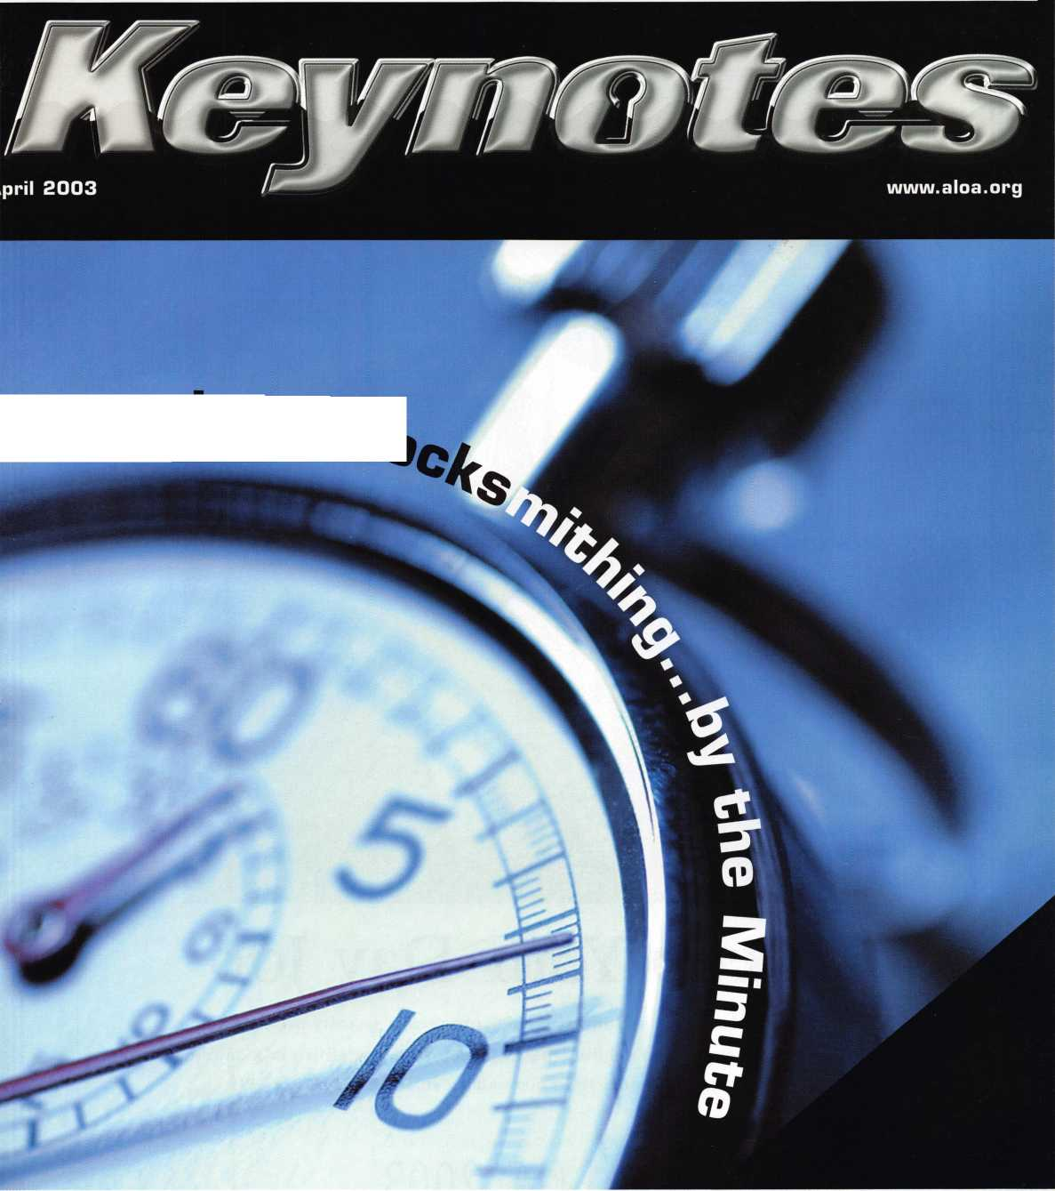

Keep Your Day Job

Come to Las Vegas and invest in your future as a security professional.

Discover classes, workshops, and exhibits that will keep you competitive in today’s marketplace,  
Las Vegas Hilton/Las Vegas Convention Center • July 14-20, 2003

The only gamble is staying home

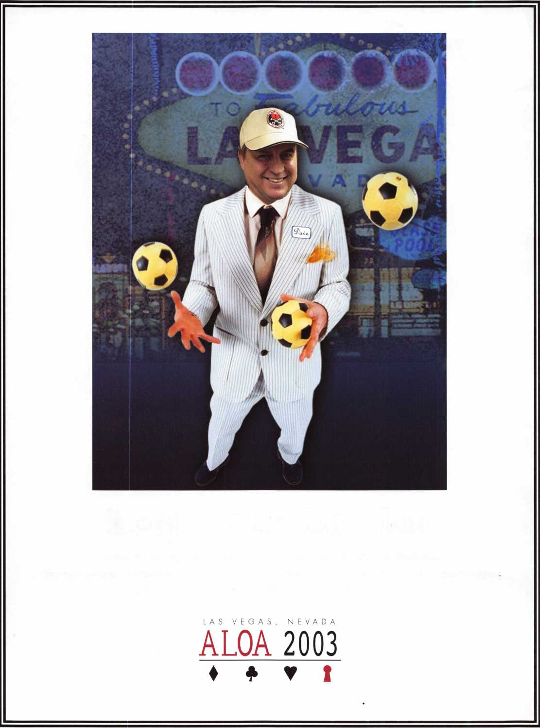

Pr°?"“s LOCKSMITH Professionals

ANDOVER LOCK & KEY SERVICE

3221 LAKESIDE HWY,  
ANDOVER MA 05242  
(508) 626-1111

**FREE Printing of Your Ad Copy on bac**

® ^ESiSffaS.

LAKE VIEW LOCKSMITH

24 Hour Service (845) 556-LOCK

Choose from Brass Plated Bead Chains or Chrome Plated Wire Rings

**AD / ID KEY TAGS**

Specifically designed to identify the product you work with daily and promote your business with your custom Ad copy.

back side of tag with 4 lines for key identification

KEYS FOR

**Clear Plastic Protective Sleeves** Stock# PPS10

Protect your key tags with  
durable plastic sleeves

W 100 200 500 1000

11.50 19.95 42.00 68.50

**Kp\/**

Size: 2Vz"xW Added security and finishing touch when presenting keys to your customers

* 100 200 500 1000

10.50 17.00 37.50 65.00

TO ORDER: Choose QTY., Key Tags with Chains or Rings, TAG COLOR and Provide Imprint Copy (printed black only).

QUANTITIES100 200 500 1000 2000 3000 5000

**it** KEY TAGS with CHAINS or RINGS 32.00 42.95 83.95 115.00 195.00 269.00 395.00

YOUR CHOICE OF CHAINS OR RINGS - IF NOT SPECIFIED WE SHIP CHAINS

**Key Tags Only (no chains or rings)** - Deduct 10% from above prices National Logos - No Charge / Custom Logos - Add $25.00 and supply clean B & W artwork

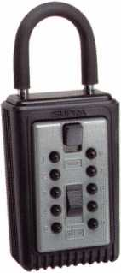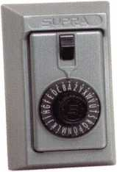

**COMBINATION KEY BOXES**

©SUPRA

**ALL METAL**

**PROFESSIONAL**

®

Key Storage Lock Box

* ALL METAL Construction  
  $/ Great Economical Pricing
* Simple to set/ Simple to open
* 5 Year Warranty

**PUSHBUTTON**

1-4 37.95 EA. / 5-9 34.95 EA.  
10 or MORE 31.95 EA.

**SERIES LOCK BOXES**

Both models now have weather resistant  
ALL TITANIUM METAL CONSTRUCTION  
with metal back and buttons. Both models  
are also available with PUSH BUTTON  
COMBINA TION LOCKS that are easy to  
set & reset.

**Stock #C3-PUSHBUTT0N**

Removable KeyBox, DoorGuar rubber bumper protects surfaces

**Stock #C3-DIAL**

Removable KeyBox  
DoorGuard rubber bumper protects surfaces

DIAL

1-4 36.95 EA. / 5-9 33.95 10 or MORE 30.95 EA.

Stock #S5-DIAL Surface Mount Unit

No Home Should Be Without One  
The Surface-Mount S-5 Supra  
Lockbox is a product you can provide to  
any homeowner, easily priced to your  
customer in the $50.00 range installed  
(simple 4 screw installation). Carry one

with you at all times to demonstrate - stock # S5-PUSHBUTTON  
once shown it sells itself!! Surface Mount Unit

ShurLok has designed an all-metal key storage box that is the safest, most secure lock box on the market. Separate easy to set combinations open the shackle and key compartment — and the combinations can be changed in seconds. The ShurLok is so simple to use a child can open it, yet so versatile it will satisfy the Real Estate professional or anyone requiring key access in a lock box. Unique double combination allows all users access to key(s) while allowing only authorized users access to the shackle and will prevent lock box removal or theft.

**1 to 9 $19.95 ea.**

**10 or more $17.95 ea.**

*if color is not specified we ship blue*

Stock #SLK100R

Brick Red

Stock #SLK100  
Blue

**Set your own combination**

The combination can be changed in seconds —  
without special tools or disassembly. Changing  
the shackle combination also automatically changes  
the combination for the sliding key storage door.

change 1°.’000

button ^Combineions

Possible!

Changing the

for the shackle  
only takes a few seconds  
with a simple turn  
of the change button.

**\*$7.00 SHIPPING CHARGE ADDED PER ORDER** NY RESIDENTS ADD APPLICABLE SALES TAX

**SANZO SPECIALTIES, INC. TOLL FREE: 1-800-222-4041**

**BOX 68 ENDICOTT, NY 13760 FAX: 607-748-0507**



***VfSA***

***Masb***



•"~~NO¥US |

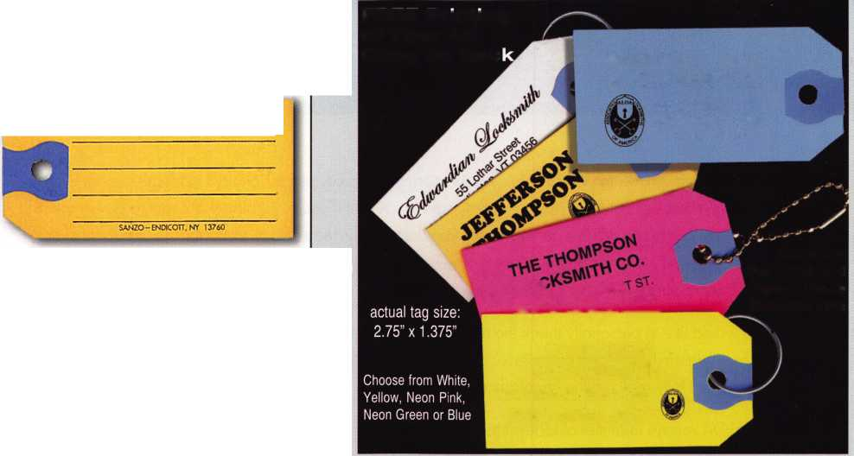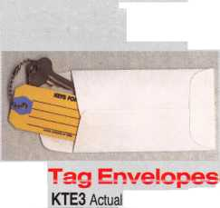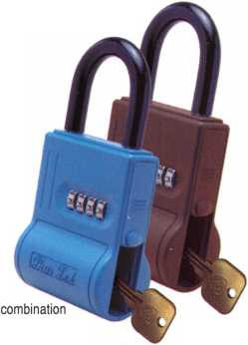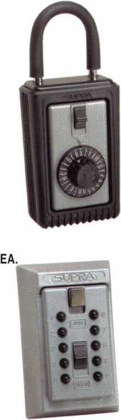

**president**

**journey**

i

s

Institutions all over the world employ a silent army of security professionals. It's difficult to even guess  
at the numbers, but these days, it's pretty safe to say that if you're running a hospital, a government  
facility, a school, an office complex, etc., you desperately need a knowledgeable, professional direc-  
tor of security. If you don't, you're effectively opening your doors to all manner of thievery, destruc-  
tion and danger for your business and your people.

I would like to personally thank the many ALOA institutional locksmiths whose hard work and pro-  
fessionalism has helped promote locksmithing and ALOA before their employers - those who would-  
n't have fully realized the importance of sound security systems without them.

ALOA repays institutional locksmiths by sounding the horns for them before institutions through our  
many promotional/advertising campaigns. We also have worked tirelessly with various institutions  
to encourage them to look for ALOA certified members to fill their locksmith job openings; that way,  
they know they're getting the best security pros in the business. We also advocate for our institu-  
tional members in various legislatures, provide them with monthly technical material in Keynotes,  
and offer them the best education available in the world through some of our institutionally-slanted  
ACE classes. When it comes down to it, ALOA doesn't isolate its institutional members in any par-  
ticular manner. Instead, we view all of our members - institutional or not - in the same light: You're  
the best security professionals in the world.

Of course, I'd be remiss if I implied that ALOA does this all on its own. We have worked very close-  
ly with local chapters and with our affiliates to help locate and then assist institutional locksmiths  
around the globe. We have also worked with our good friends over at the Institutional Locksmiths'  
Association. The members and officers of ILA (some of whom regularly contribute to Keynotes) are  
to be commended for working with ALOA for the good of institutional locksmiths everywhere. They  
could just as easily worked against ALOA, and I commend them for wanting to work together for

the good of all.

See you next month,

Randy Simpson, CML



|Q Keynotes • April 2003

f

e

a

t

u

r

e

s

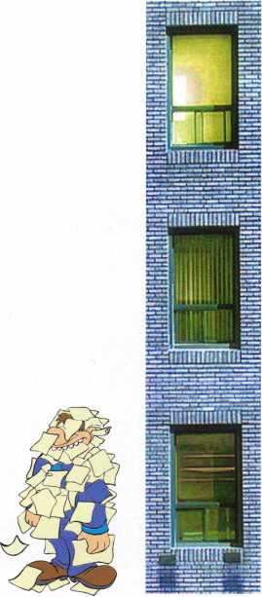

Institutional



Institutional Locksmithing by the Minute ByvemonKeiiy,cpL Time is money. Time is of the essence. Time stands still for no man. Time marches on. Times are tough. It's all about Time these days - especially when you're an institutional locksmith at the College of New Jersey.

Securing an Apartment House By Merritt Perkins, RL

The owner of an apartment house in my hometown had security problems.

They would find drunks and homeless people sleeping in the halls, children tak­ing shortcuts through the building, salesmen going from door to door, etc. The tenants did not feel safe when nonresidents could enter the building.

Something had to be done, and that's where I entered the picture.

Tools:



Life Safety and Security with

LockOne's LKM7000 8/ Charles Stephenson, CPS, OS

Every locksmith has to deal with life safety issues in the day-to-day performance of their work. With this in mind, Lockmasters has introduced a family of high security solutions under the name LockOne(r) and in this article, we will cover the LKM7000, a new life safety exit device designed to revolutionize single motion egress.

Automotive:



NGS Service Functions

Tom Seroogy

The service features are used to make changes or adjustments to the various systems within the vehicle. For the locksmith, adding keys is the most common of these functions. Changing time delays, indicator chimes, vehicle calibra­tions, programming keyless remote fobs, ABS functions are others.

Safes



GSA File 6 File Cabinet Safes

8/ Greg Perry, CML, CPS

Although you may find file safes in private industry or even in residential use, these safes were designed and produced for use by the Federal government and defense contractors.

Business



Know Your Employer John Eiihtt, *cml, cps*

We have failed to check out the companies that we desire to work for or even the ones where we are currently working.

**departments**

Executive 5

Applicants 6

Core 7

Calendar 8

Legislative Update 36

Classifieds .. .40

Associate

Members 42

Back Page ....44

Visit our website at [www.aloa.org](http://www.aloa.org)



***Visit our Website on  
www. stamcctv. com***

THE COMPLETE

CCTV PROGRAM ON CD-ROM  
FOR STAFF TRAINING AND

PRODUCTIVITY ENHANCEMENT

STAM Insight has been  
developed to enhance CCTV

skills and productivity with  
many different uses.

# Productivity

**W** System Drawing **W** Estimation **II** CCTV Training **W** CCTV Reference 1# Sales/Demo System Design V Staff Evaluation

**INFOMATE WORKMATE ULTIMATE**

CCTV Content

CCTV Calculators

**10 hours**

**/**

Demonstration Tool

*1

r

Estimation

m

Drawing

*m*

Internet Enabled

**No**

Pre-Test

**No**

Quizzes

**No**

yfl Knowledge Assessment

NO

m m 0 0

Sold in Over 50 Countries

Distributed by:



3003 Live Oak Street  
Dallas,Texas 75204

COPYRIGHT © 1996 Security Training and Marketing Pty Ltd.  
All rights reserved ACN 057 006 541

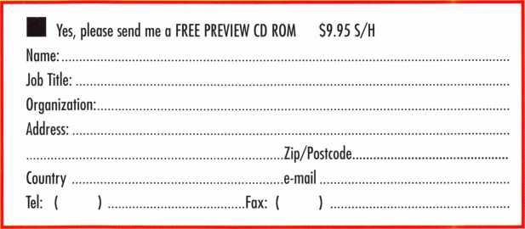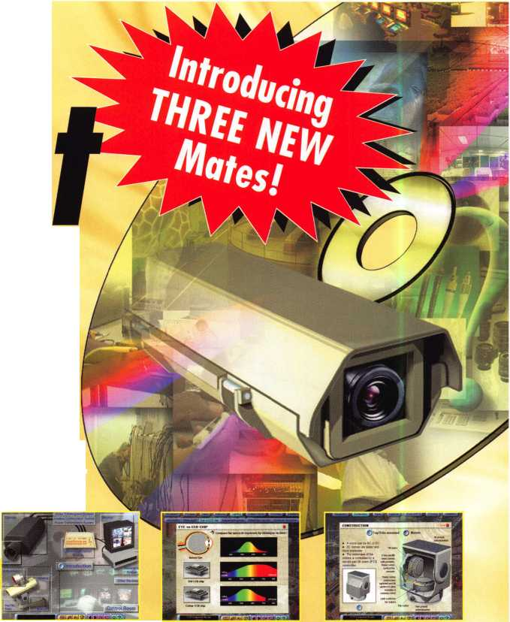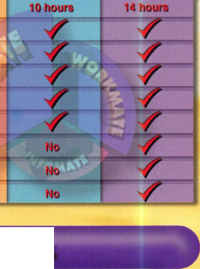

**executive**

Volume 49, Issue 4



Additional contact information for the ALOA Board and most Keynotes authors is  
available through "Locksmith Search'" on the ALOA Web site- [www.aloa.org](http://www.aloa.org) or by  
contacting the ALOA office at 3003 Live Oak Street; Dallas, TX 75204; (800)532-2562;  
FAX (214)827-1810; e-mail [aloa@aloa.org](mailto:aloa@aloa.org).

|  |  |
| --- | --- |
| Editor  Jim DeSimone | [editor@aloa.org](mailto:editor@aloa.org) |
| Technical Editor  David Lowell, CML, CMST .... | [david@aloa.org](mailto:david@aloa.org) |
| Editorial Advisor  John D. Cannon, CML | .[jdcannon@worldnet.att.net](mailto:jdcannon@worldnet.att.net) |
| Art Director  Betty Henderson | [betty@aloa.org](mailto:betty@aloa.org) |
| Advertising Sales  Kim Hammond | voice; 817-645-6778  Fax: 817-645-7599 e-mail: [adsales@aloa.org](mailto:adsales@aloa.org) |
| Executive Director  Charles W. Gibson, Jr., CAE | [charlie@aloa.org](mailto:charlie@aloa.org) |
| Convention & Meetings Manager  Jo Anne Mims [joanne@aloa.org](mailto:joanne@aloa.org) | |

PRP/Education Manager

David Lowell, CML, CMST [david@aloa.org](mailto:david@aloa.org)

Operations/Membership Manager

Mary May [mary@aloa.org](mailto:mary@aloa.org)

IT Operations Manager

Greg Jackson [greg@aloa.org](mailto:greg@aloa.org)

Comptroller Kathy J. Romo

Membership Coordinator Shelly Jett

Convention & Meetings Assistant Karen Lyons PRP/Education Coordinator Janelle Ramirez

Accounting Coordinator Stephanie Brothers

Mail Room Coordinator Kevin Wesley

Receptionist Shawn Alvear

Contributors

Jerome Andrews, CML  
Paul Chandler, CRL  
Claire Cohen, CML  
Brian Costley, CML, CMST  
Ray D'Adamo, CML

Sal Dulcamaro, CML Billy Edwards, CML Dan Graffeo, CRL,CMST AJ. Hoffman, CML Jeff Nunberg, CML, CMST

Mike Oehlert, CPL, CPS Randy Simpson, CML Robert Stafford, CML Dave Thielen, CML Greg Perry, CML,CPS

Tom Seroogy Charles Stephenson, CPS Dennis Watanabe, CML, CMST

Mission Statement: The Associated Locksmiths of America, Inc. is dedicated to enhancing the professionalism, education and ethics among locksmiths and those in related sectors of the physical security industry. With approximately 10,000 members in the United States, Canada and the freeworld, ALOA is poised to help members obtain the knowledge, the strength, and the confidence to perform their role in the physical security field with pride and dignity. But it is only through active involvement and participation that ALOA can fully achieve its potential—and can help members to achieve theirs.

Policies: Keynotes® is the official publication of the Associated Locksmiths of America, Inc. (ALOA). Keynotes® acts as a moderator without approving, disapproving, or guaranteeing the validity or accuracy of any data, claim, or opinion appearing under a byline or obtained or quoted from an acknowl­edged source. The opinions expressed by the authors do not necessarily reflect the official views of ALOA. Also, appearance of advertisements and new products or service information does not constitute an endorsement of products or services featured by the Association. The Association does not accept responsibility for the inaccuracy of any data, claim, or opinion appearing in this publication, due to typographical errors on the part of the authors, Association staff or its agents.

Editor's Note: This publication is designed to provide accurate and authoritative information in regard to the subject matter covered. It is provided and disseminated with the understanding that the publisher is not engaged in rendering legal or other professional services. If legal advice and other expert assistance is required, the services of a competent professional should be sought.

Authors' Payment: Payment for eligible submissions to Keynotes will be based on the following criteria: topic, time spent and past contributions. Authors who regularly submit to Keynotes® are generally paid a higher rate. The latter is especially true of authors who write to fit specific editorial needs and submit said copy by Keynotes® deadlines. As a general guideline: Average payment for a 750 word, business or light' technical article would be $200. Payment for a 1500 word article involving significantly higher time and research efforts would be $400.

Payment will not be offered for articles submitted by ALOA employees or members of the ALOA Board of Directors (unless material is of a technical nature), nor for articles submitted by a company that promote that company's products or services. ALOA reserves the right not to pay for articles sub­mitted by an individual(s) that promote a particular company's products or services.

Disclaimer: The Associated Locksmiths of America, Inc., (ALOA), reserves the right to refuse any article for any reason. Additionally, ALOA reserves the right to edit, amend or modify any article submitted for publication in order to preserve technical accuracy, clarity, fairness or grammatical cor­rectness. ALOA will make the best efforts to notify the author of any changes. The extent of ALOA's liability for any article or information contained therein will be a notice of correction or retraction in the next possible issue.

Keynotes® (ISSN 0277 0792) is published monthly except for the combined June/July issue by The Associated Locksmiths of America, Inc., 3003 Live Oak St., Dallas, TX 75204-6186. Telephone: (214) 827-1701; FAX (214) 827-1810; e-mail [aloa@aloa.org](mailto:aloa@aloa.org). Subscription rates for members—$15.00 per year. Business class postage paid at Dallas, Texas. POSTMASTER: Send address changes to: Keynotes, 3003 Live Oak St., Dallas, TX 75204-6186. © Copyright 2003, All rights reserved. No part of the contents may be reproduced or reprinted in any form without prior written permission of the publisher.

President

Randy Simpson, CML

1. 780-7026

[president@aloa.org](mailto:president@aloa.org)

Secretary

John D. Cannon, CML  
(703) 960-6413  
[secretary@aloa.org](mailto:secretary@aloa.org)

Directors, Northeast

Robert E. Mock  
(215)624-5035  
ned i rector@a ioa. org

Peter Saraiiian, CRL  
(973)890-9797  
nedirecfor@aioa .org

William L. Young, CML

(610) 647-5042  
[nedirector@aloa.org](mailto:nedirector@aloa.org)

Directors, Southeast

Vincent Formon, CML, CPS

(901) 324-2910  
sed i rector@a!oa. org

Donald E. Rule, CML  
(662) 324-2658  
sedi rector@aloa .org

Directors, North Central

Mark E. Blum, CML, CPS  
(517) 482-5809  
ncd irecfor@aloa .org

John Soderland, CML, CMST  
(414) 327-5625

[prolock@aloa.com](mailto:prolock@aloa.com)

Director, South Central

i CD Lipscomb, CML, CPS (903)874-3522 [scdirector@aloa.org](mailto:scdirector@aloa.org)

Directors, Southwest

Gordon R. Racine, CML  
(719) 384-4707  
[swdirector@aloa.org](mailto:swdirector@aloa.org)

Julie McCluney, CRL

1. 636-5652 swdirector@aloa .org

Director, Northwest

Scott L. Henke, CPL, CPS  
(907) 248-3785  
nwd i rector@aloa. org

Director, European

Hans Mejishede, CML

(453)539-3939

[eurdirector@aloa.org](mailto:eurdirector@aloa.org)

Director, Asian

JoeJ. Lee, CRL  
(215)289-2404  
[asiandirector@aloa.org](mailto:asiandirector@aloa.org)

Director, Associate

Paul M. Justen  
(800)333-6953  
[asdirecfor@aloa.org](mailto:asdirecfor@aloa.org)

Trustees

[trustees@aloa.org](mailto:trustees@aloa.org)

John j. Greenan, CML, CPS  
(773) 486.2030

Dallas Brooks  
(334) 826-8990

David M. Lowell, CML, CMST  
(800) 532-2562

Past Presidents

1999-2001 John Greenan, CML, CPS 1997-1999 Dallas C. Brooks 1995-1997 David Lowell, CML, CMST 1993-1995 Breck Camp, CML 1991-1993 Henry Printz, CML 1989-1991 Evelyn Wersonick, CML, CPS 1987-1989 Leonard Passarello, CPL 1985-1987 Joe Jackman, CML 1983-1985 Stanley Haney, CPL 1981-1983 Louis LaGreco, CPL 1979-1981 John Kerr, RL | 1977-1979 Clifford Cox, CML 1974-1977 Charles Hetherington 1972-1974 Gene Laughridge 1970-1972 William Dutcher, RL 1968-1970 Constant Maffey, RL 1966-1968 Harold Edelstein, RL 1964-1966 William Meacham : 1962-1964 Robert Rackliffe, CPL 1960-1962 Edwin Toepfer, RL 1956-1960 Ernest Johannesen

Keynotes • April 2003



|  |  |  |  |  |
| --- | --- | --- | --- | --- |
| AK |  | FL | Olathe Guttenberg | TN |

Anchorage

Larry E. Scanlon

Sponsor: Brooke P Berry CRL

AL

Birmingham

Richard W. Waits

Sponsor: Robert J. McCormick CRL

Eureka Springs

Jeanette McDonald

Sponsor: John J. Ruperd

AZ

Apache Junction

Chad M. Karabel

Sponsor: John Alik CRL, CPS

Phoenix

Daniel R. Johnson Jr

Sponsor: William Lee CRL

*CA*

Tracy

Manuel Borba

Sponsor: George E. Phipps RL

CO

Cheraw

Garvin O'Hare

Sponsor: Gordon R. Racine CML

CT

Ledyard

Robert Watrous Jr

Sponsor: J David Vessels CRL

Middleburg

Bob Grace III

Sponsor: Vincent L. Formon CML CPS

Tampa Ed Jurewicz

Sponsor: Gary L Cooper

*GA*

Tucker

Elmar Avila

IL

Calumet City

Wayne E. Merrick

Chicago

Karl D. Barnes

Sponsor: Vincent Glispie CRL

Henry Greene

Sponsor: Vincent Glispie CRL

Granite City

Larry M. Brooks

Sponsor: Kathy A. Zaniolo CPL

Troy

James R. Criswell

Sponsor: Terrill L. Smith

IN

Hammond

Wendy R. Ostrander

Sponsor: Vincent Glispie CRL

Merrillville

Bryan K. Holem

Sponsor: Vincent Glispie CRL

KS

Dodge City

Brent H. Whitaker

Sponsor: Elvis D. Hammerschmidt CPL

Gregory J. Bovee

Sponsor: Rollin R. Gilliland CPL CPS

Overland Park

Joseph E. Buckingham

Sponsor: Royce L. Welch

Alan Dale

Sponsor: Royce L. Welch Parsons

Stephen Passwater

Sponsor: Clifford D. Lipscomb CML,, CPS

MA

Randolph Joseph Bukin

Sponsor: Barry McMenimon

MD

Glen Burnie

Gregory Boyer

Sponsor: Robbie Buss

ME

York Beach

Gregory C. MacGlashing

Sponsor: Peter J. Roche CRL

Ml

Detroit

Larry Walker

Flint

Delano W. Barnes

Redford

Virginia Smith

NJ

Cliffside Park

Andrew Devoto Jr

Sponsor: Norman Parent

Joseph N. Travelli

Holmdel

Anthony Chadwick

Sponsor: George Weickert III

NM

Tijeras

Jay C. Dodge

Sponsor: Stephen W. Smith

NY

Averill Park

Michael N. Fresina

Sponsor: Frank M. Commisso

Bronx

Alfredo Hernandez

OH

Kent

Robert Batian

Marion

Jeff Cranmer

Sponsor: Douglas C. Pritchard CRL

OK

Perry

Sam Ebersole

Sponsor: John J. Ruperd

OR

Dundee

William Mulholland

PA

Philadelphia

Shannon M. Cropper

Memphis

Jeff D. Harrison Jr, CRL

Sponsor: Vincent L. Formon CML CPS

TX

Longview

Ben C. Coulter CRL

UT

Ogden

Nathan R. Smith

Sponsor: DeloyJ. Hamblin CPL

VA

Leesburg

David Popish

Sponsor: Aaron B. Greenburg

WA

Four Lakes

Joel D. Anderson

Sponsor: Jane S. Anderson



Rho-Milano Italy

Donatello Baracco

Sponsor: Luciano Fidani



Ware Hertfordshire

Matt Worboys

Sponsor: Ken Dale

Plumstead London

Gordon L. Ford

These applicants are scheduled for clearance as members of ALOA. The names are published for member review and comment within  
30 days of this Keynotes issue date, respectively, to ensure applicants meet standards of ALOA's Code of Ethics. Protests, if any, should  
be addressed to the Membership Department and must be signed. Active Membership applicants (a) have worked in the industry two or  
more years. Allied Membership (AL) applicants are not locksmiths, but work in a security-related field. Apprentice Membership (AP)

applicants have worked in the industry less than two years.

Keynotes • April 2003

core

Ford Gumboil Notes

This is a follow-up to the article, "The Ford  
Fiasco," (March 2003 Keynotes, pgs. 24-27)  
by Eric Costley, CRL, on keying the Ford gum-  
ball machine. Too bad the folks at Eric's shop  
didn't know about my extensive collection of  
odd cylinders and the fact that these machines  
all left the factory keyed alike!

Although it's too late to help Eric's customer,  
perhaps the close-ups (photos 1 and 2) of my

cylinder and original key will help someone else. Note that the bit-  
ting actually breaks through the blade in places!

Rather than starting with a plain piece of brass, Dennis Rider, a locksmith buddy here in southern California, starts with a Borkey 1459 (photo 3) blank and uses a Keyway King machine to mill the key section.

A. J. FHoffman, CML

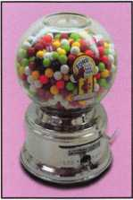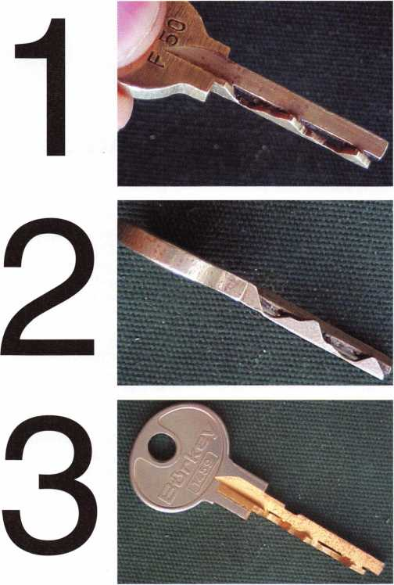

New Certifications

NEW CRLS

Jorgenson, Paul F.

Webster, MN

Nissen, David C.

Rochester, MN

Polyard, Steven W.

Wabasha, MN

Coulter, Ben C.

Longview, TX

James, Jeff D.

Lake Dallas, TX

Middleman, John Chicago, IL

NEW CPS

Bernier, Daniel D.

Dayton, MN

In Memory

Laura M. Berich (ALOA member #6983), of Reedsville, PA, recent­ly passed away. She had been a key punch operator at Penn State University, and also was co-owner of Bob's Locksmith, also in Reedsville. On behalf of everyone at ALOA, we wish to extend our deep sympathy to the family and friends of Mrs. Berich.

Let Us Know!

If you have an opinion to offer on ALOA, the state of the industry, or life in general, we want to know about it! Submissions to the "Mailbox" section of Keynotes are printed on a space-available basis. Write to: "Letters to the Editor"; ALOA; 3003 Live Oak Street; Dallas, TX, 75240; FAX 214/827-1810; e-mail: [editor@aloa.org](mailto:editor@aloa.org).

Need Help?

At ALOA, we want to make sure you are getting as much bang for your membership dues buck as we are able to give you. If you have had problems getting membership services, or have a ques­tion regarding member services, please contact Bill Gibson, execu­tive director, at 800/532-2562 ext. 15, or e-mail: [charlie@aloa.org](mailto:charlie@aloa.org).

Keynotes • April 2003



JUNE I MAY APR

**upcoming**

|  |  |
| --- | --- |
| 2 Ohio Valley Chapter of ALOA  Membership Meeting 7pm Ryan's Steak Flouse  Middletown, OH (off exit 32) Mehdi Zahedi (937) 294-4241 | 8 Greater Houston Locksmith Assoc 16 Central Florida Locksmith Assoc. 17 Fla. West Coast Locksmiths Assn.  Membership Meeting 7:30pm Membership Meeting 7:30pm Monthly meeting 8:00pm  Judy Clifford (979) 297-2413 Orlando, FL • Jim Riley Education: Hayman Safes  <http://ghla.lcis.com/index.html> (863)294-8679 James Barnhardt  [ernie28@ix.netcom.com](mailto:ernie28@ix.netcom.com) |
| 26 Nebraska Locksmith Association Educational Classes 9am - 5pm Omaha, NE • Bernard Dobesh (308) 381-4440 [Keyman3@charter.net](mailto:Keyman3@charter.net) | 29 San Diego Chapter of ALOA/CLA 29-3 Security Hardware Distributors  Membership Meeting 6:30pm Assoc. Annual Membership Conf.  Linda Vista Village Clubhouse Ponte Verde Beach, FL  2750 Wheatstone St., San Diego Talbot Gee 215-564-3484  Mike Perry (858) 967-9761 [www.shda.org](http://www.shda.org) |
| 3 California Locksmiths Assoc.  Trade Show and Education Ontario Convention Center Suzanne Harmony 714-632-6800 (see adpg31) | 7 Ohio Valley Chapter of ALOA 13 Greater Houston Locksmith Assoc 15 Fla. West Coast Locksmiths Assn.  Membership Meeting 7pm Membership Meeting 7:30pm Monthly meeting 8:00pm  Ryan's Steak House Judy Clifford (979) 297-2413 Education: Paul Butler with MDS  Middletown, OH (off exit 32) <http://ghla.lcis.com/index.html> James Barnhardt  Mehdi Zahedi (937) 294-4241 [ernie28@ix.netcom.com](mailto:ernie28@ix.netcom.com) |
|  |  |

|  |  |  |  |
| --- | --- | --- | --- |
| 4 Ohio Valley Chapter of ALOA | 24 | San Diego Chapter of | 25 Pacific Locksmith Association |
| Membership Meeting 7pm |  | ALOA/CLA | Membership Meeting 6:30pm |
| Ryan's Steak House |  | Membership Meeting 6:30pm | Denny's Restaurant Tualatin, OR |
| Mehdi Zahedi (937) 294-4241 |  | Linda Vista Village Clubhouse | Dan Cunningham 360-835-1191 |
|  |  | Mike Perry (858) 967-9761 | [www.pla-pro.org](http://www.pla-pro.org) |

|  |  |  |  |
| --- | --- | --- | --- |
| UPCOMING PRP SITTINGS | | 6/22/2003 | 8:00AM • Reno, NV  Clark Security Products  Joan Emrick 619/718-7308 |
| 4/5/2003 | 9:00AM • Somerset, NJ • MLANJ |  |
|  | Dan McGlynn, CML 732/932-9857 | 7/10/2003 | 8:00AM • Dallas, TX • ALOA |
| 4/5/2003 | 9:00 AM • Layton, UT |  | Janelle Ramirez 800/532-2562 X30 |
|  | Beehive St. Locksmth Assoc.  Deloy Hamblin 801/621-5625 | 7/19/2003 | 8:00AM • Las Vegas, NV • ALOA Janelle Ramirez 800/532-2562 X30 |
|  | Madalyn Smith | 7/20/2003 | 8:00AM • Las Vegas, NV • ALOA |
| 4/6/2003 | 8:00AM • Chicago, IL |  | Janelle Ramirez 800/532-2562 X30 |
|  | Clark Security Products  Joan Emrick 619/718-7308 | 8/7/2003 | 8:00AM • Dallas, TX • ALOA  Janelle Ramirez 800/532-2562 X30 |
| 4/10/2003 | 8:00AM • Dallas, TX • ALOA  Janelle Ramirez 800/532-2562 X30 | 9/11/2003 | 8:00AM • Dallas, TX • ALOA  Janelle Ramirez 800/532-2562 X30 |
| 4/26/2003 | 6:00PM • Denver, CO  CO Front Range Chapter  Gordon Racine, CML 719/384-4707 | 9/21/2003 | 8:00AM • Anaheim, CA  Clark Security Products  Joan Emrick 619/718-7308 |
| 5/8/2003 | 8:00AM • Dallas, TX • ALOA  Janelle Ramirez 800/532-2562 X30 | 10/9/2003 | 8:00AM • Dallas, TX • ALOA  Janelle Ramirez 800/532-2562 X30 |
| 5/16/2003 | 6:00PM • St. Charles, MO  Bi-State Chapter  Kenneth Kim, CPL 314/351-7252 | 10/18/2003 | 10:00AM • Chamblee, GA  GA Chapter of ALOA  John C. Elliott,Jr.,CML,CPS |
| 5/17/2003 | 5:00PM • Seattle, WA |  | 770/314-7859 |
|  | KDL Hardware Supply, Inc.  Julie Pilgrim800/926-7716 or 206/682-7383 | 10/25/2003 | 9:00 AM • Sturbridge, MA  Yankee Security Convention  Jack Hobin 800/209-8266 |
| 6/1/2003 | 8:30AM • Lewistown, MT  Montana Chapter of ALOA | 11/13/2003 | 8:00AM • Dallas, TX • ALOA  Janelle Ramirez 800/532-2562 X30 |
| 6/12/2003 | Michael Alexander 406/549-5625 | 12/11/2003 | 8:00AM • Dallas, TX • ALOA |
| 8:00AM • Dallas, TX • ALOA  Janelle Ramirez 800/532-2562 X30 | Janelle Ramirez 800/532-2562 X30 |

UPCOMING ACE CLASSES

April 3-6 April 5-6 April 24-26

May 16-18

May 17-18 June 14

July 14-18

Somerset, NJ • MLANJ  
Dan McGlynn, CML  
732/932-9857

Atlanta, GA • GA Chapter Of ALOA  
John C. Elliott, Jr., CML,CPS  
770/384-7859

Denver, Colorado • Colorado Front  
Range Chapter of ALOA  
Gordon Racine, CML  
719/384-4707

St Charles, MO • Bi-State Chapter  
Kenneth Kim, CRL, CPS  
314/351-7252

Birmingham, AL • AL Locksmith Assoc.  
Amanda Floyd • 334/793-5060  
Vancouver, BC (Canada)

BC Association Of Security Profsnls.  
Jerune Rodermond 604-607-6604  
Las Vegas, NV • ALOA  
David Lowell, CML, CMST  
800/532-2562 xl8  
(75 ALOA ACE Classes)

**events**

25-27 Wyoming Locksmith Assoc. Spring Meeting

Casper Day's Inn • Casper, WY Larry Capp (605) 642-4846

24 Greater Houston 27 San Diego Chapter of ALOA/CLA 28 Pacific Locksmith Association

Locksmiths Assn. Membership Meeting 6:30pm Membership Meeting 6:30pm

Interchangeable Cores Class Linda Vista Village Clubhouse Denny's Restaurant Tualatin, OR

Ed Stiles (979)323-9919 2750 Wheatstone St., San Diego Dan Cunningham 360-835-1191

Mike Perry (858) 967-9761 [www.pla-pro.org](http://www.pla-pro.org)

23 Pacific Locksmith Association Membership Meeting 6:30pm Denny's Restaurant Tualatin, OR Dan Cunningham 360-835-1191 [www.pla-pro.org](http://www.pla-pro.org)

24-26 Colorado Security Professionals Education Conference Denver, CO • Gordon Racine, CML 719-384-4707 [racine@rural-com.com](mailto:racine@rural-com.com)

25-26 Grtr. Houston Locksmith Assoc.

Auto Key Making in 10 Mins or Less H.L. Flake and Houston Auto Show Ed Stites 979-323-9919

New Product

SAFE CORPORATION *T*u

Viking Stainless

Fire & Burglary Protection  
State of the Art Composite Fill

Strong • Functional • Attractive

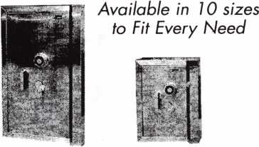

See us at [www.a-bsafecorp.com](http://www.a-bsafecorp.com)

1*-*800*-*253*-J 267 Fax* 856*-*863-1208

CALL FOR YOUR CATALOG TODAY

**sional Business Product**

**ds the Key to**

**Savings’-** d&Mjk

**lock on spe»*«yv*ty|**

**„er&SAVE!Q^**

**Buying From Nebs**

**For more information, visit us online: [www.professionalbusinessproducts.com](http://www.professionalbusinessproducts.com) or call 1-800-355-6322 for our catalog.**

*Professional*

*Business*

*Products*

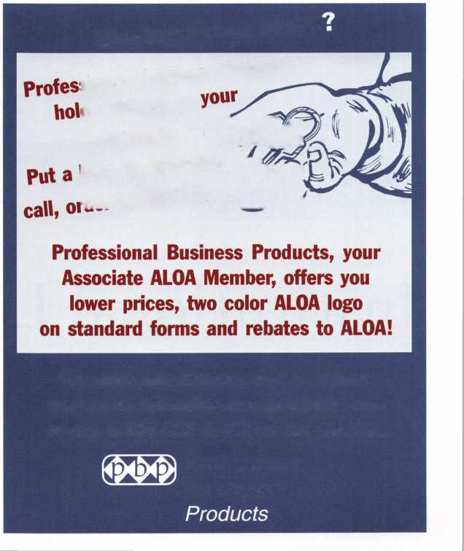

Institutional Locksmithing...

by the Minute

By Vernon Kelley, CPL

Keynotes • April 2003

Time is money Time is of the essence. Time stands still for no man. Time  
marches on. Times are tough. It’s all about Time these days.

We've all thought about it time after time after time... (get it?). It seems  
that the more important an object or concept is to society the more pedes-  
trian the expressions describing it seem to get. (To prove my point—think of  
all of the colloquialisms there are that describe money.)

Of course, nowhere is time more important than at work where you're paid  
(very handsomely I hope) to provide a certain amount of service within a  
given timeframe. And when you work at an institution, you'll probably have  
to quantify your time very precisely so that your position can be justified  
every year at budget time. Since I can't quantify my job the way a lock-  
smith-for-hire does (with money earned for the company), I need to do it  
with good old-fashioned, government approved, paperwork—and lots of it!  
Which is exactly how I can write such a timely, minute-by-minute account  
of an institutional locksmith's day. I have cesspools of paperwork to help me  
relive the moment!

To set the stage for our journey through an institutional locksmith's day-in-  
time, here is a cast of characters whose time I get to manage. I am the  
Access Control Specialist and Supervisor of the Office of Access Control  
Services under the Department of Administrative and Environmental  
Services at The College of New Jersey located in Ewing, New Jersey. (Try fit-  
ting that on a business card.) I work with Dan Aker, a locksmith with over  
30 years of locksmithing and hardware experience, and Carlos Higgins, an  
electronic technician who works almost exclusively on the college's net-  
worked access control systems. Our shop also has a student technical assis-  
tant (let's call him a locksmith's helper), and a student office assistant.

And now, for our journey through time...

The date that I've chosen to relive for your entertainment, through the wondrous magic of paper work, is Tuesday, August 27, 2002. I chose this date since The College is in the thick of fall semester start-up activities, and is just about to open its brand new Science Complex. A semester startup is fiendishly hectic by itself. Now add a freshly constructed building with over 300 new doors and locks (which brings our campus total to close to 8,000 doors), and you can almost feel the excitement (said sarcastically) of the day building yourself.

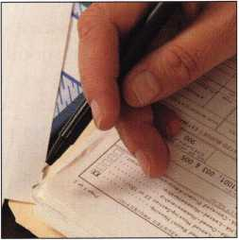

When you work at an institution, you'll probably have to quantify your time very precisely so that your position can be justified every year at budget time.

Keynotes • April 2003

7:08 a.m.

Our shop’s hours of operation are from 7:30 a.m. to 5:30 p.m. So why am I here 22 minutes early? PAPERWORK. I have to check the voicemail on our phone exten­sion used for emergency work orders and our online system used for non-emergencies. One irritat­ing aspect of the job is separating real emergency work (a student can't access their dorm with their cardkey) from imagined emergency work (someone locking their Fig Newtons in their desk). Of course, all of this work needs to be organ­ized and prioritized by writing (what else?) work orders. Then there are numerous e-mail mes­sages to check and respond to, timesheets to process, reports to complete and send to the boss, key requests to review for proper authorization, orders for supplies to write and place with distribu­tors, key records to update, yada yada yada, so forth and so on.

I think you get the picture. I'll spend anywhere from 20 minutes to two and a half-hours a day pro­cessing paperwork. After all, paperwork is the fuel that keeps the government furnace boiling!

8:15 a.m.

It's time to meet with the Science Complex general contractor. It's the same old problem over and over again. Our campus uses Corbin Russwin master ring cylin­ders and mortise locksets. Here's the problem: When the doors are ordered, the general contractor never informs the door manufac­turer that the mortise cylinder holes need to be prepped for mas­ter ring cylinders (or "jumbo cylin­der," as it is sometimes called), not

standard cylinders. The prep for a master ring cylinder needs to be 1 5/8-inch diameter, not the standard prep of 1 1/4-inch diameter. All of this means that my locksmith con­tractor can't possibly install any cylinders until this predicament is corrected. Of course, I'm the only one who notices this small over­sight. (Well, let's be honest — I'm the only one who wasn't trying to ignore it!) I inform the GC.

Now, what do you think that a good general contractor should do in a situation like this? Should he (a) have his crew fix the door, (b) call the door manufacturer to offer some solutions or, (c) call my office for some advice on how to remedy his little quandary. If you answered a, b, or c, you'd be WRONG and soundly booted out of general con­tractor school for even hinting that a general contractor could possibly make a mistake. A good GC would fire off an e-mail to var­ious campus officials asking what my office was going to do to cor­rect the situation. After my boss forwards the e-mail to me (since I obviously don't rank as a campus official of any importance),

I inform the GC that I plan to do NOTHING about the sorry state of affairs that the doors are in.

I didn't write the specs for the door, I wasn't asked to plan review the specs, I didn't place the order, and I sure didn't install the doors anyway, even though it was painful­ly obvious that the cylinder holes were the wrong diameter when the locksets were installed.

That was last week. My boss has evidently won the e-mail war (he usually does), and now the GC is humbly asking for some of my pearls of wisdom that will put an



Keynotes • April 2003

end to the cylinder-hole crisis. I tell him the solution is simple. Get some hole saws with replaceable arbors and put the 1 1/4 inside the 1 5/8. The smaller hole saw will act as a guide for the larger one. No routing, no filing, no ruined doors. So simple ... a locksmith could fig­ure it out. By the way, after saving the GC thousands of dollars and dozens of man hours, I'm still waiting for a thank you today. So much for common courtesy

9:42 a.m.

I'm back at the office. I'll spend the rest of the morning processing key requests. Before the day is through, I'll process about 75 key requests. It seems that some peo­ple like to wait until the last minute to request keys just to see if their keys will be done in time. What fun! I just love playing this game!

Completing a key request is a very simple undertaking. How people can make the process so compli­cated is beyond my pea-brain com­prehension. Write in your name and contact information, the building and room you need a key for, and have your supervisor sign it — that's it. Follow the rules (which are all spelled out on the form) and you'll get your keys, post haste. But this is what we get: illegible handwriting, incorrect building or room information, peo­ple requesting keys that are already assigned to them, people insisting that we accept faxed requests (we don't), people insisting that we deliver their keys (again, no) and (my personal favorite) forged authorization signatures!

Regardless of the difficulties, our office faces processing key

requests, we have a 98.5 percent successful completion rate.

I think that is pretty doggone good, cowboy

11:25 a.m.

Lunch time. Lock the doors and turn off the phones. (That’s the only way to get 30 minutes of peace and quiet on a day like this.) Even still, I'll check in with the boss, check my e-mail again, and check the emergency work order voice mail. In between, I'll peruse one of eight trade magazines (including Keynotes, naturally) to which I subscribe. It's my job to know about new products and techniques that can make work just a little easier. Work smarter, not harder I always say (usually while banging my head against a wall somewhere).

Noon

Lunch is over, (and how). A power problem at one of the Townhouse clusters has resulted in the online access control system going offline. This is a common problem for this system, but it is an infuriatingly constant problem at the Townhouses. You can't get into the houses; you can't get out of the houses. Period.

When one or two doors go down, it's not a big deal. But when 23 of 29 houses go down, it becomes a controlled-chaos team effort. The whole office is involved. One per­son (usually me) views the system in real time at a computer in the office while the rest of access con­trol staff go to each house, find out which ones are offline and turn off the power to the affected build­ings. Then, they will remove the

control boards that are frozen in each house, clear the memory, reinstall the board and wait for the board to receive a fresh download from the server (I hate modern technology). We've done this so often that we can handle a prob­lem this big in about two hours.

Naturally, I'm doing all sorts of other stuff while I'm in the shop between sending commands to the freshly rebooted units from the office computer.

1:37 Pm-

Now we're getting just a little busy. I actually have to go out on cam­pus and do some honest-to-good- ness, get-your-hands-dirty lock work (gasp!).

As you can see, I don't do a lot of work on campus. Dan does most of the lock work in the field. I'm mostly the "shop guy," pinning cylinders, duplicating keys, repair­ing locksets, and just generally keeping the shop running as smoothly as possible. The shop is extremely well organized, and it needs to be. We have a tremen­dous amount of stock and file keys to keep track of, and only so much space in which to do it.

Today is different. I'm actually relieved to have to fix something - anything —mechanical. I get to enjoy the concrete, sustentative results of my work, which isn't something I can often say about doing paperwork and attending meetings. The work orders that I usually take with me are of the "hit-and-run" variety. Strike adjust­ments, lock changes, downloading an audit trail from a stand-alone electronic lockset, generally quick jobs so that Dan can fry the bigger

fish without interruption. But I'll be back soon.

2:15 p.m.

I'm back! It's time to have a brief meeting with one of the College's managing architects. Plans are in the works to construct a shiny, new library building. And to the College's credit, some one realizes that, after 13 years in the locksmith business, I might actually know a thing or two about door hardware! They've asked me to specify the panic hardware for the exterior doors, and I'm more than happy to oblige.

Now, if I had to give someone advice on how to be an efficient and effective institutional lock­smith (such as myself), and could only use only one word, this is the declaration that I'd utter: Standardize. I standardize every­thing, and I mean everything. Forms, key blank storage, parts bins, key location records, you name it. Heck, I even order the same exact type of pen from the office supply store each and every time, so that all of our records are always in the same ink and point size (black, medium ball point, please)!

I bring up my standardization dogma because the managing architect has just mentioned my favorite word (well, my favorite at work anyway). The college and, more importantly, her department are very interested in developing across-the-board door hardware standards for all pending construc­tion. This is music to my ears, especially since the college is a mere two years into its 10-year, $250 million "construction renais­sance." I know that it's going to be

Keynotes • April 2003

a lot of work, but I tell her that I'll begin a list of suggestions for her department in October. I actually look forward to doing it, too.

3:05 p.m.

It’s time to have a meeting with the boss. I report to Chris Chamberlin. He is the Assistant Director of the Department of Administrative and Environmental Services. (Another business card printing nightmare.) No, he's not a locksmith, and has no background in this line of work. Frankly, the college pays me to understand door hardware, not Chris. Some tradesmen get very agitated when they have to report to a boss who doesn't know how to do "their" job. So what? I'm sure that the CEO of Coke has absolutely no idea how to fix the bottling line when it breaks. He probably does­n't even know the recipe for Coke.

This meeting will be quick, about 15 minutes since we've been in con­stant contact all day via e-mail, phone, and two-way radio. He's in another office altogether, so there are days that we don't even see each other. He has a lot of other responsibilities, so I try to make any contact as brief and to the point as I can without speaking too much locksmith-ese.

At this meeting, we'll go over some little details like updates on pending work, reviewing incomplete key requests, discussing personnel issues, approving purchases, tweaking poli­cy etc. Some meetings are more involved, like implementing a new policy, an upcoming install of a mas­ter key system in a new building, or just making sure that we're "on the same page" on a specific issue. Projecting an united front is extremely important, especially con­cerning the enforcement of some of the more unpopular policies.

As bosses go, I think that Chris is a good boss (and I'm not just say­ing that because he's going to read this article). He does the one thing that a good boss should do: He keeps the monkeys off my back so I can do my job. In return, I make him look good to his boss. It's a good deal.

3:23 p.m.

The student residents have only been back a week and we already have to do lock changes. (That's not even close to a record. Once, we had to change a lock 90 min­utes after a resident moved in because she had already lost her key.) I still have excellent vision and nimble fingers, so I can pin cylinders very quickly. I'll prepare a half a dozen cylinders to be installed tomorrow.

Pinning cylinders isn't hard; main­taining a 30-year-old master key system is. We do the best that we can by using only original manufac­turer pins and key blanks, and duplicating all keys from a factory or code-cut original key. The col­lege is in the process of installing two new master key systems, (one for academic buildings, one resi­dence halls), but the policy has been to only do the work in con­junction with new construction or major renovation of a building. It is the college's serendipitous good fortune that they have installed almost nothing but master ring cylinders over the years. If stan­dard cylinders were used, you could imagine all manor of hijinx that would be going on (and so could many lawyers, I'm sure) with a system so old. Let's just hope that our luck doesn't run out any time soon.

4:50 p.m.

What am I still doing here? I get done at 4 o'clock! There is always overtime at this time of year, and we could probably stay late every night if we wanted. Usually, we are so overwhelmed with key requests that I often ask for some OT just to try to keep up with demand (and to placate the demanding).

Overtime is not always available, except for emergencies, and that's fine by me. So when I tell the boss that there isn't any particular emergency but that we need to stay late, he usually gives us the green light. I'm not one who wants to be at work any more that I have to; I have a life you know!

9:37 p.m.

So much for having a life. I was just contacted at home by campus police about a problem with a resi­dence hall being secured when it's supposed to be unlocked. (They don't usually lock down until mid­night.) This I one instance when I just love modern technology. The college has (very thoughtfully) pro­vided me with a laptop computer so that I can dial into the online access control system from home. Instead of driving back to the col­lege, all I have to do is bring the system up on the computer and send a command to the door to be in the "unlocked" mode instead of the "controlled" mode -- all from the comfort of my humble domi­cile. Ain't technology grand?

Boy, how time flies! That's it for Institutional Locksmithing...by the Minute. See you next time.



Keynotes • April 2003

crwor* -

CEN.XXXXXX

kaba koupon A

Sard Stop Refresh Home

o €Aie#j

The Kaba Mas Dealer Network is the second phase of our new distribution channel that includes sales support, technical support services, product development and technical training classes. The first step was to create a network of wholesalers - the Wholesale Network - who all received extensive in-house training on all of our products and are supported by our internal and external sales team. By providing our distribution channel with education and sales support, they are better equipped to service your product needs.



**KABA The Brand for Safe Locks**

MAC **u/tA/tA/ l/oho_moo** r^r\mn

A Member of the Kaba Group

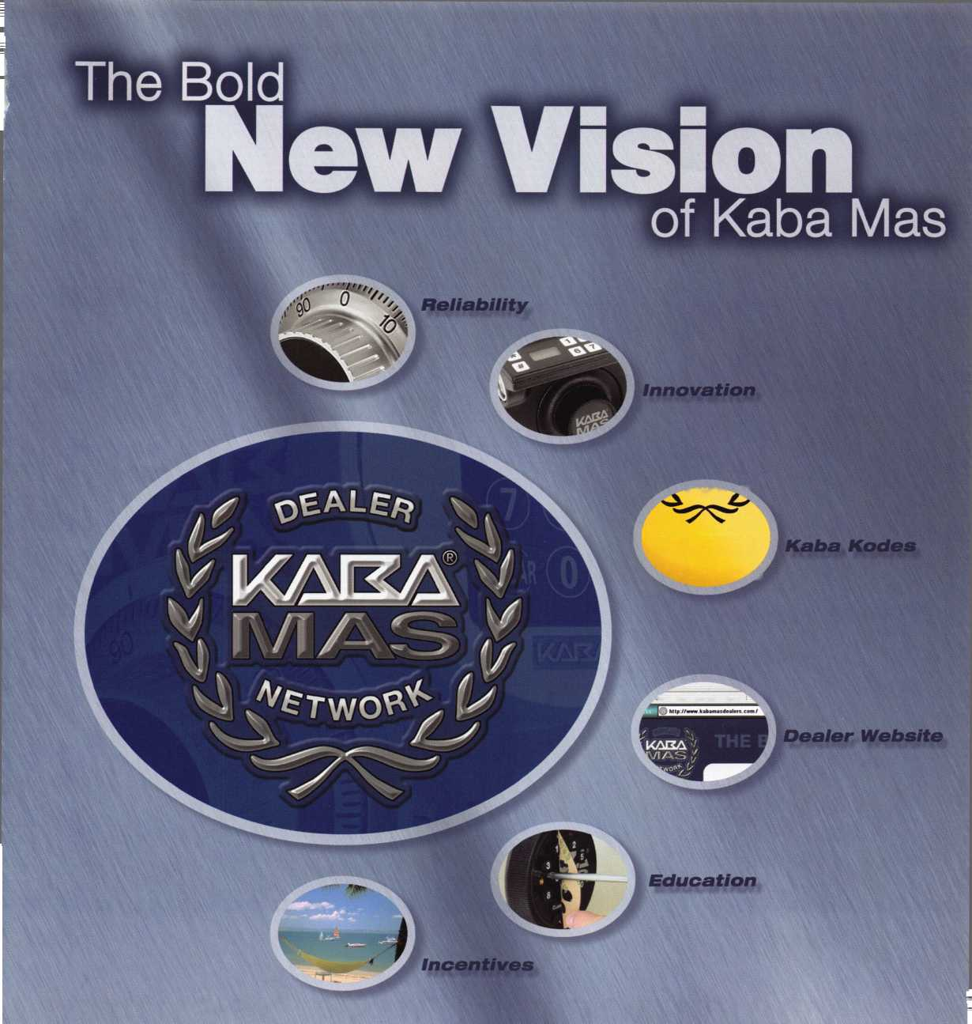

Apartment House Security

By Merritt Perkins, RL



Keynotes • April 2003



The owner of an apartment house in my hometown had security problems. They would find drunks and homeless people sleeping in the halls, children taking shortcuts through the building, salesmen going from door to door, etc. The tenants did not feel safe with nonresidents could enter the building.

The building is like two apartment houses side-by-side. There were three floors; one side had five apartments on each floor and the other side had six apartments. Each side had its own entrance front and back. The unlocked front entrance doors lead to a hallway where the stairway leading to the upper floors and the mailboxes were located. On each floor, a hallway through the center of the building leads from front to back. There is a heavy wood fire door opening out at each end of the hallway

The building was built on sloping ground, so the back doors are lower than the front doors. Inside each back door is a landing with stairways leading up to the apart­ments and down into the basement. In the basement are the laundry room, recreation room, and storage rooms accessible to all residents. A contractor replaced the older back doors with new glass doors with aluminum frame using AdamsRite AR-4510-LH locks. It was necessary to replace the cylinders furnished by the contractor with cylinders keyed so that the residents could use their apart­ment key to open the door.

Pushing in on the lock's latch bolt and turning the key backwards will lock the latch bolt in the retracted position so that the door remains unlocked until someone turns a key in the unlocking direction when the latch bolt is released when removing the key

These doors had heavy door closers to resist the action of wind and you have to keep the key turned while opening the door, so many people got in the habit of using the key to pull the door open. To deal with this situation, I made special cams so that when the latch bolt is fully retracted, the key will remain turned while you open the door with the handle. It was necessary to cut away a little of the stop inside the lock with a carbide burr. In order to install the lock cylinder in the lock (or remove it), it is necessary to insert a key and turn it a quarter turn so that the cam can go through the opening.

Arrow vestibule locksets were chosen for the front hallway doors after it was found that Dexter Duralocks were not available with a vestibule function. The Arrow locksets were modified so that Dexter Duralock 6-pin cylinders could be used with them. The outside cylinder was pinned so that the keys to all of the apartments would operate it, while the inside cylinder was pinned so that it would be operated only by a master key. The inside cylinder could unlock the outside knob so that it was free to turn (or lock)

so that it would  
require a key to  
unlock it.

Observing people  
entering with both  
arms full, it was  
noticed that they  
had to use one hand  
to turn the key and  
the other hand to  
turn the knob, so the  
lock was modified so  
that the key could  
remain turned while  
the hand was free to  
turn the knob.

An installation jig  
was made to control

the drill bit and hole saw to  
accurately position the holes.

The hole through the door  
was cut part way through  
with a hole saw and finished  
from the other side to pre-  
vent splintering of the wood.

Drive-in dead latch bolts  
were used.

To admit visitors, an intercom system was needed so that a visitor could call the apartment from the lobby and a per­son in the apartment could release the lock to admit the visitor. While the building was under construction, the owner installed five conductor cables from just inside each apartment door to the basement for a future intercom sys­tem. There was no record to show where these cables were located. The mailboxes in the lobbies had panels with pushbuttons for the intercom system, a panel with a glass window for a directory and a panel with slots in it for a loudspeaker.

The building owner purchased a commercial intercom sys­tem consisting of apartment units, electric strikes for the entrance doors, loudspeakers to reinstall next to the push buttons in the lobby, and one amplifier and control unit for each side of the building, and then asked me to install it.

I decided that it was not suitable and that new amplifiers and control units were needed to meet the requirements of the building.

The salesman had suggested that the electric strikes on the doors of the three floors be connected together so that all doors would be released at the same time. A visitor on the first floor would be close to the entrance door, then would take some time to climb to the third floor and the person

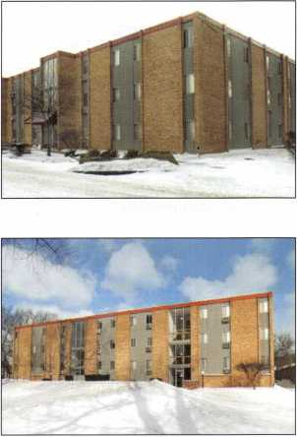

Keynotes • April 2003

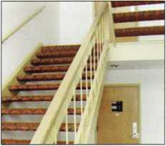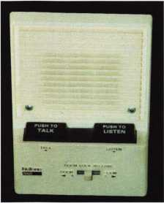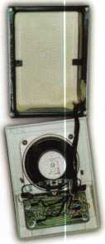

Apartment Wall Unit-Before and after removal.

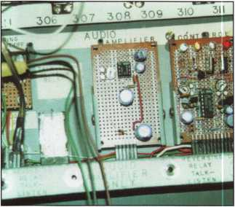

Audio Chassis

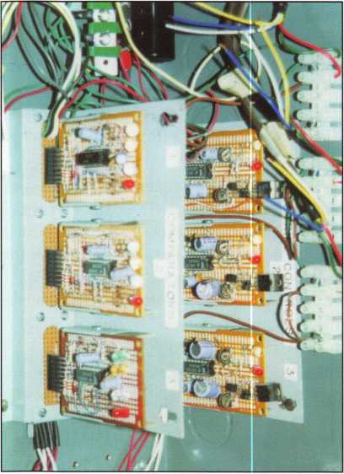

in the apartment would have to guess when to release the door again. The electric strikes are designed for only momentary operation, to be energized for only a few seconds at a time; oth­erwise, they're likely to overheat and burn out.

I installed the apartment units close to the entrance doors of the apartments and used the lobby loudspeakers and discarded the rest. The lobby loudspeakers were held in place by brackets attached to the sides in the panel by flat- head machine screws, so that no screws extended through the front of the panel. Screen was placed over the slots on the inside to keep children from sticking objects through the slots. The labels for the push buttons were printed on the rough side of drafting film using a computer program to reverse the letters so that they would read normally with the glossy side out. This avoided the multiple reflections if clear plastic had been used. Bright white paper was put behind them to reflect the light.

The control cabinets were located in the basement below the mail­boxes. The switches in the apart­ment units connect different resistors to control circuit, which lead to a comparator for each floor in the control box. When the talk bar is pressed, the timer for the audio amplifier is turned

on and the fourfold double throw switch reverses the amplifier so that the apartment can talk to the speaker in the lobby. When the "listen" bar is pressed, there is no resistor connected to the control circuit, so the timer keeps the audio amplifier operating for about 20 seconds.

When the door switch is pressed, it starts a double timer on the strike control unit. The first part of the timer controls the time delay before the door releases; the second part controls the time that the door remains released. A resistor from the input of the power supply limits the current to the strike to just enough to keep it released so that there is no danger of the strike burning out. After the resistor, a capacitor charges to the full voltage of the power supply and provides enough energy to make the strike pull in. When the door switch is pressed to the door two position, it resets the timer, lock­ing the door.

Getting locked out

There should always be someone present around the building with a master key, so that they can let in people who get locked out.

In one incident, a man's wife was sick and he called an ambulance.

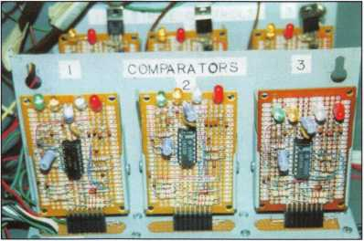

Inside Cabinet-Strike controls and comparators

8

Keynotes • April 2003

He went out to let the people  
from the ambulance in and found  
himself locked out because he  
had left his keys in the apart-  
ment. The owner had hired a  
new manager and a few days later,  
he did not respond. The owner  
used his master key to enter the  
apartment and found his new  
manager sitting in a chair, dead.  
One of the tenants told the own-  
ers that they were expecting visi-  
tors from out-of-town. They were  
not at home when the visitors  
arrived but since the owners had  
been told that the visitors were  
expected they let the visitors into  
the apartment.

Mail Boxes

The mailbox locks were made  
by Hudson, and if you keep a  
record of the code numbers,  
the keys can be cut by code.

It is not practical to take these  
locks apart to change the pins, so  
it is best to just replace the lock.  
The keys should be stamped with  
the code number.

Laundry equipment, coin boxes

Tubular keys are used on many  
coin boxes and it is a convenience  
if they are all keyed alike. One  
common problem was the mecha-  
nism jamming when a Canadian  
quarter was used.

Garages

The owner purchased adjoining  
property and built carports,  
which he later converted to  
garages that are rented to resi-  
dents. In some cases, they are  
also used for storage. There have  
been problems with radio con-  
trolled garage door openers not  
working properly and was neces-  
sary to get in some other way.

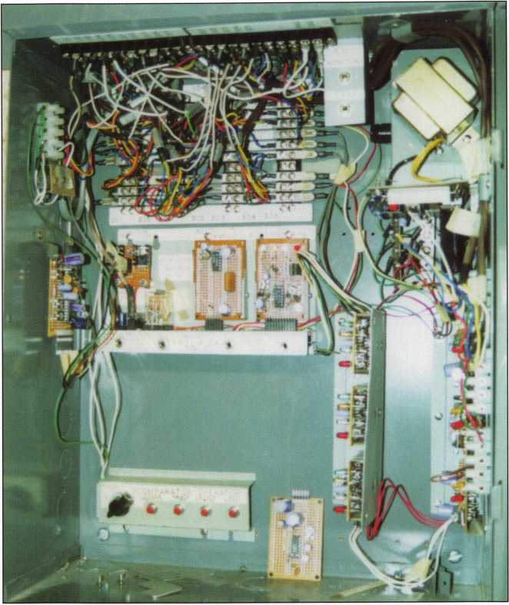

Inside Cabinet, showing all components

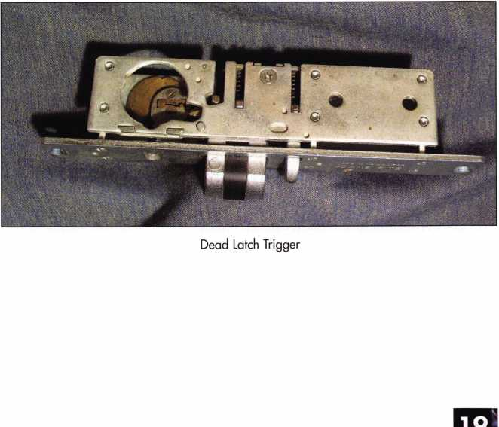

Keynotes • April 2003

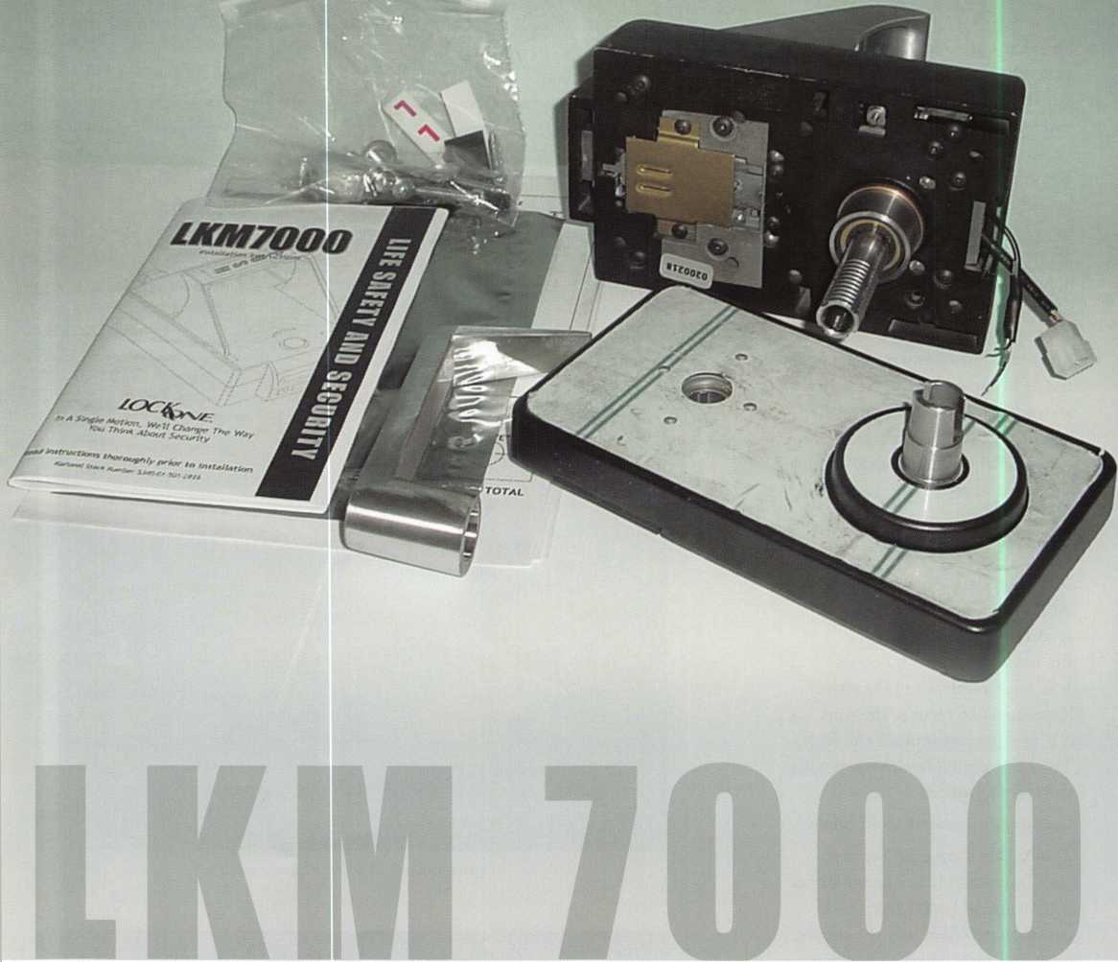

Every locksmith has to deal with life safety issues in the day-to-day performance of their work. With this in mind, Lockmasters has introduced a family of high security solutions under the name LockOne^ and in this article, I will cover the LKM7000, a new life safety exit device designed to revolutionize single motion egress.

The LKM7000 meets FF-L-2890, a government specification. While the original intention was to meet the needs of security doors for Closed Areas and SCIF (Secure Compartmentive Information Facility) Areas, the LKM7000 will provide a solution to many other and less stringent applications. I will concentrate on the government applications in this article, but you will quickly see other opportunities in your service area.

A "closed area" contains collateral, classified information maps, documents, projects, weapons storage, etc.

As loosely spelled out in specification DoD 5200.i-R. A closed area is usually secured with a security door (no DoD specification) and steel frame. No sound rating is required of the door, but the lock must guard against surreptitious entry and be fitted with a cipher lock or lever set, and/or electronic access control.

Keynotes • April 2003

LIFE SAFETY and SECURITY with LockOne's LKM7000

Charles Stephenson, CPS, CJS

A SCIF door typically provides some degree of sound deadening and guards against surreptitious entry Applications include, but are not limited to, meeting rooms, cryptology rooms, auditoriums, labs, R&D areas, etc. Such areas are widely used by the intelli­gence community

Currently, a pedestrian door lock combined with a combination lock meeting FF-L-2740A (Kaba Mas CDX09, 08, 07) is required in addition to a cipher lock and/or access control. The problem with having two different door locks on the door is that it could require two motions to exit the room. Fire Marshals can levy large fines upon discovery of this configura­tion; yet security officers cannot substitute the securi­ty of the XO product. The events of Sept, n, 2001, quickly elevated life safety to priority status for the Federal Government, contractors and sub-contractors.

The LKM7000 works in conjunction with a variety of high-security locking devices, access control, alarm and monitoring devices. This versatility lends itself to environments where secrecy is paramount, including law enforcement, manufacturers, banks, etc.

Let’s address the outside of the LKM7000 as seen in photographs 1 and 2. The lock may be a Kaba Mas X- 09, X-08 or X-07, Auditcon and Cencon, Sargent & Greenleaf 8400, 8500, one of the 6120 series of elec­

tronic safe locks or the 6804 or 6805 keylock, LaGard 3330,1985, 2200 keylock, one of the 33E series or LG Audit safe locks, Ilco 673, 684 and the GlobaLoks XLN. When mechanical combination locks are employed, the combination may be changed without special effort via the change keyhole as seen in photo

1. This impressive list of locks will provide the level of security your client demands. Access control can also be integrated in the form of a swipe card, proximity readers, traditional keypad devices or biometrics.

The lever mechanism is protected from excessive force with a heavy-duty, non-slip clutch.

The LKM7000 is non-handed, so no special planning is required when confronted with different door scenarios.

The inside of the door is seen in photos 3 and 4. First you notice the compact and clean attractive appear­ance, rather than the typical ’’industrial” looks of the past. The single motion (push or pull) egress handle eliminates the need for a free hand here. The wires appearing from the rear of the unit provide 12-volt or 24-volt input when employing an access control sys­tem. Remove the resistor for the 12-volt application.

The larger electrical terminal provides connections when bolt sensors are needed. The internal switches



Keynotes • April 2003

1. LKM7000 with an X08

monitor the position of both the combination lock bolt and the LKM7000 bolt. Simply tie the bolt monitoring system to an alarm or other monitoring system and you have elevated security considerably.

The LKM7000 features a deadbolt that is encapsu­lated by the strike and provides reinforced security by resisting override. Those of you who are familiar with Pedestrian door locks such as the Kaba Mas CDXo and S&G SM50 recognize that this feature has been tested and proven through years of use by the U.S. Government.

Photo 4 shows a key cylinder at the left side of the lock. This key cylinder provides the optional Lock- Down feature. The Lock-Down feature, when engaged, will disable both the outside locking and/or access control device, while still providing for a safe, single motion egress from inside. The Lock-Down feature might be used when the occupants of a room want to be isolated and prevent entry by anyone. Also, if a room has multiple doors, the Lock-Down feature can be used to funnel traffic through one door. A word of caution, though: When the Lock- Down feature is engaged, there is danger of a lockout of an unoccupied room. You will notice the "sight window" adjacent to the key cylinder, which provides a red or yellow flag for easy visual verification of the locking status.

The LKM7000 is made to take the abuse of heavy usage; all moving parts are made of stainless steel or brass to prevent premature wear.

Photo 5 shows the entire package as received and ready to install. You can see the lock comes scored for easy sawing to accommodate doors from a 1 1/8 inch to 2 5/8 inch thickness.

The warranty by Lockmasters is a full year on the LKM7000 unit and, of course, the lock is covered by its manufacturer's warranty.

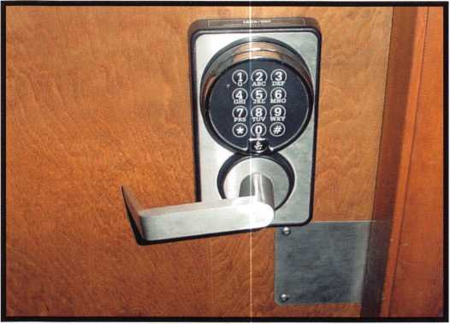

2. LKM7000 with a S&G 6120

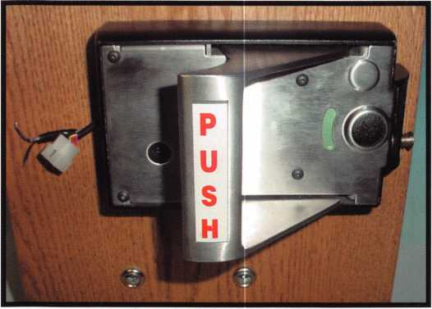

3. Notice change key hole, connectors for alarms,  
monitoring and acces control

Keynotes • April 2003

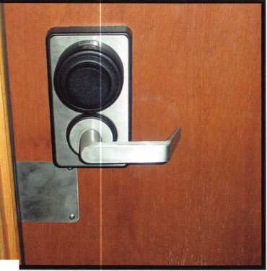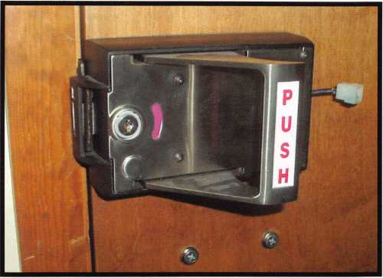

4. Notice the optional key cylinder

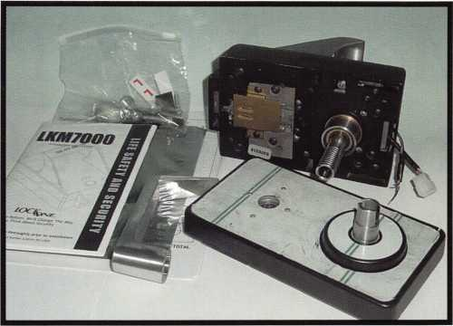

5. LKM7000 "out of the box"

There you have it for now — the first introduction by LockOne®. You can expect more introductions in the future as the family of high security solutions grows.

I want to thank Kevin Moores for his considerable help in preparing this article. The next article will cover the installation of the LKM7000, so be sure to look for it!

If you want more information on the LockOne LKM7000, you may contact Kevin Moores at Lockmasters 1-800-654-0637.

**WHEN SERVICING**

**IN ERCHANGEABLE CORE PRODUC S, HAS I EVER SEEMED LIKE SOME HING WAS MISSING?**

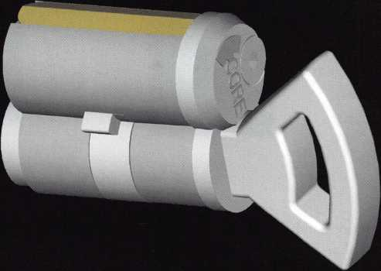

**T-CORE™**

**T-CORE™: “Rear thumbturns for Small Format Interchangeable  
Core (SFIC) cylinders, including Best®, Arrow™ and Falcon™.**

ALOA members please respond to recorded message.

Call toll free 1 (866) 839-6286  
e-mail tcore@ev1 .net

**Patent pending**

Keynotes • April 2003

More NGS Tips from the Pit Crew

By Tom Seroogy



Our last article outlined the basic functions and diagnostic features available to locksmiths using Ford's NGS diagnostic tool. You may remember that as a complete Ford diagnostic tool, the NGS offers the locksmith not only the ability to program keys, but also to perform critical diagnostic tests and repairs as well.

To briefly review, the locksmith typically needs to perform one of two tasks on a vehicle - service or diagnostics.

The important locksmith-related diagnostic features of the NGS include retrieving and clearing Diagnostic Data Codes or DTCs and Parameter Identification Data or PIDs. These functions allow the locksmith to review the various vehicle systems for trouble that may prevent successful key programming and/or retrieve important system information - i.e., the number of keys already programmed into the vehicle, status of SPARE KEY SWITCH function, and the master code for vehicles equipped with keypad entry systems. Diagnostic functions are available by using either the RED or BLACK Diagnostic cards.



Keynotes • April 2003

The service features are used to make changes or adjust­ments to the various systems within the vehicle. For the locksmith, adding keys is the most common of these func­tions. Changing time delays, indicator chimes, vehicle cali­brations, programming keyless remote fobs, ABS functions are others. In order to access the service functions, the GREEN Service card must be used.

The service functions most critical to the locksmith are:

1. IGNITION KEY CODE PROGRAM
2. IGNITION KEY CODE ERASE
3. SPARE KEY SWITCH ENABLE/DISABLE
4. PARAMETER RESET
5. SET UNLIMITED TRANSPONDER CODE
6. UNLIMITED KEY ENABLE/DISABLE

Probably the single most common use for the NGS by a locksmith is adding or generating keys for a PATS- equipped Ford vehicle. The IGNITION KEY CODE PROGRAM, IGNITION KEY CODE ERASE and SPARE KEY SWITCH ENABLE/DISABLE functions of the NGS handle these important tasks, and are covered in the rest of this article.

Our next article covers the less frequently used, but still important PARAMETER RESET, SET UNLIMITED TRANSPONDER CODE, and UNLIMITED KEY ENABLE/DISABLE functions.

Getting Started

First off, let's take a quick look at a few important points on programming Ford vehicles.

To date, Ford employs two PATS systems commonly known as PATS I and PATS II. Because the requirements and pro­cedures for programming keys under each system vary, this article covers the latest and much more common PATS II procedures. For more information on programming keys to PATS I-equipped vehicles, contact Lockmasters.

Let's first look at the requirements and limitations for programming a PATS I I-equipped vehicle:

1. A maximum of eight keys can be programmed into the vehicle while it is in the Standard Mode. While in the Standard Mode, if the maximum eight keys have been entered into the car, attempts at adding additional keys will not work. For most Fords, this is the only available mode. However, many late model Fords are now offering

the Unlimited Key function. As its name implies, this function allows an unlimited number of keys to be pro­grammed into the vehicle. This function is covered in more detail in a later article.

1. Two working and programmed keys are required to add more duplicate keys into the vehicle using onboard pro­gramming procedures. If less than two keys exist, the NGS is required to add more keys.

Drawing from our previous article, there are five steps to accessing the key programming functions. After inserting the correct transponder key into the ignition and turning to the ON position:

1. Select and trigger ENTER SERVICE BAY FUNCTIONS from the menu.
2. Select and trigger the module holding the PATS function for the vehicle being programmed. (See NGS Basics in the November 2002 Keynotes, pages 18-21, for more information on Ford modules.)
3. Select and trigger ENTER SECURITY ACCESS from the menu.
4. Select and trigger the Year and Model of the vehicle being serviced. Once triggered, ACCESS DELAY - 10 MINUTES will be displayed on the NGS screen. Sit back and relax. Once the 10 minutes has lapsed the next and final menu appears.
5. Select and trigger the six desired functions (mentioned above) from the menu.

Key Programming Options

Now that we've reached the last menu, we can select one of our key programming functions from the menu. Let's look at them now.

IGNITION KEY CODE PROGRAM

This function is used strictly for adding keys to the vehicle. When selected and triggered, the non-programmed key in the ignition is automatically written and stored to the memory of the vehicles module. PROGRAMMING SUC­CESSFUL appears on the screen, indicating a successful programming. If the key was previously programmed into the vehicle, KEY ALREADY PROGRAMMED appears on the screen. If eight keys have already been programmed into the vehicle, PROGRAM NOT SUCCESSFUL appears on the screen. This option is best when security issues from lost or stolen keys are not an issue. Using this option simply adds another key to the list of keys already operat-



Keynotes • April 2003

ing the vehicle. Previously programmed keys ARE NOT erased and will continue to operate the vehicle.

It should also be noted that this function can be used to add just one key to the car, even when there are no existing keys. This makes it perfect for generating a single new key for wholesale vehicles, rental vehicles, or travelers that may have a set of working keys at home, or with family or friends and do not need or want them to be erased.

NOTE: To add additional keys, once PROGRAMMING SUCCESSFUL appears, hit the CANCEL button to return to the key-programming menu. Insert a new non-pro- grammed key into the ignition and turn to the ON posi­tion. Select and trigger IGNITION KEY CODE PRO­GRAM again. Add up to the full eight keys allowed by that vehicle.

IGNITION KEY CODE ERASE

This function erases all programmed keys from the mod­ule’s memory. Once completed, two correctly cut keys need to be programmed into the vehicle. These keys can either be brand new keys or keys that had previously operated the vehicle. Make sure and have these two keys ready before beginning this procedure. Set one key aside, hereinafter referred to as the "second” key. Insert the other or "first" key into the ignition lock and turn to the ON position.

Select and trigger IGNITION KEY CODE ERASE from the menu. PROCESS COMPLETE or PROGRAMMING SUCCESSFUL appears on the screen.

When finished, turn the ignition to the OFF position, remove the first key from the lock and set it aside, discon­nect the NGS from the vehicle, and wait io to 20 seconds. Insert the second key (the one that was set aside) into the ignition and turn to the ON position. The THEFT lamp will light for approximately two seconds and go out. When the light goes out, turn the ignition OFF and remove the key Insert the first key and turn to the ON position. The THEFT lamp will light for approximately two seconds. When the light goes out the key is programmed.

NOTE: When programming the two keys, if the THEFT lamp flashes rapidly when inserting the key, take it out and use the other key.

It should also be noted that several NGS disconnect proce­dures have been published. The one above is the latest at the writing of this article.

Because this function eliminates the use of all previously programmed keys, it is perfect for situations where security is a concern - i.e. new owner of a used car, stolen or lost keys, domestic disputes, etc.

SPARE KEY SWITCH ENABLE/DISABLE

Fords equipped with a PATS II system allow for onboard programming of duplicate keys. The only requirement for using this method is the presence of two programmed and working keys. Although this feature is available on all Ford vehicles equipped with PATS II, the SPARE KEY SWITCH ENABLE/DISABLE function allows the techni­cian to turn this function on and off.

Standard PATS II onboard programming procedures are as follows:

1. Duplicate the bitting onto the correct PATS transponder blank. Set this key aside.
2. Insert the first programmed and working key into the ignition lock and turn to the ON position. The THEFT lamp lights solid for approximately two seconds and goes out. Turn the ignition to the OFF position and remove the key.
3. Insert the second programmed and working key into the ignition lock and turn to the ON position. The THEFT lamp lights solid for approximately two seconds and goes out. Turn the ignition to the OFF position and remove the key.
4. Insert the non-programmed key into the ignition lock and turn to the ON position. The THEFT lamp lights solid for approximately two seconds and goes out. When the lamp goes out, the key is programmed and ready to start the vehicle.

NOTE: To avoid programming problems and creating Diagnostic Trouble Codes, Ford recommends that transponder keys not inserted into the ignition lock be kept a minimum distance of 18" away from the ignition lock.

To either allow or prevent onboard key programming, select and trigger the desired function from the menu.

To allow onboard programming of keys, simply select and trigger the SPARE KEY SWITCH ENABLE fimction from the menu. Programming of additional keys using the onboard programming procedures can be used. This is the default value of all vehicles shipped from the factory.

To prevent onboard programming of keys, select and trig­ger the SPARE KEY SWITCH DISABLE fimction on the menu. Once programming is complete, key duplication can­not be done using the onboard process. To add keys when this function is selected, an NGS or other diagnostic tool is required.



Keynotes • April 2003

By default, the SPARE KEY SWITCH function is ENABLED on all new vehicles. Often, however, dealers or rental agencies DISABLE this function to prevent owners or customers from easily creating duplicate keys.

Should you come across a Ford vehicle that does not accept duplicate keys using the onboard procedures, there is a pos­sibility that this function has been disabled. This can be quickly verified by checking the status of the SPARE KEY SWITCH function using the PARAMETER IDENTFI- CATION or PID information available using the proper diagnostic card.

NOTE: Throughout the last few years, many discrepancies have surfaced relating to this function. In some early instances, the ENABLE/DISABLE statuses were reversed - e.g. when ENABLED, keys could not be programmed; and when DISABLED, key programming was permitted. There have also been instances where changing the status of the function does not actually affect the ability to add keys using the onboard programming procedure. To date, noth­ing has been released by Ford addressing these bugs.

Our next article will take us through the remaining Service functions - PARAMETER RESET, SET UNLIMITED TRANSPONDER CODE, and UNLIMITED KEY ENABLE/DISABLE.

For more information on Ford programming or transponder technolgy, contact Lockmasters at (800) 654-0637.

TURPI tO

WHOLESALE SERVICE

In-Stock... **SAFES** FREE Freight Program Fax: 800-391-4553

800**-**848-9790

AMSBC FireKing Gaidall HAYMAN MEIUNK \/lCTOR.

Keynotes • April 2003

**2**

GSA Class 6 File Cabinets

By Greg Perry, CML, CPS

This month, we'll look at three different GSA Class 6 file safes, manufactured by three different companies (Art Metal U.S.A. Incorporated, Mosler and Hamilton Products Group). Of the three, only Hamilton is still in business. Art Metal ceased operations some time in the late 1980s after the government removed the GSA approval. Mosler filed bankruptcy in 2001, and its assets were pur­chased by Diebold, so they may be produced again under the Diebold name (or perhaps a name like "Mosler Division of Diebold"). Although you may find file safes in private industry or even in residential use, these safes were designed and produced for use by the Federal government and defense contractors. Class 6 containers are required to provide 30 man-minutes against surrepti­tious entry, 20 man-hours against manipulation of the lock, 20 man­hours against radiological attack, and no forced entry requirements.

Although the requirement may offer no forced entry time, these safes do provide a pretty good degree of pro­tection against forced entry. Two general vintages have been produced black label and red label. The black label containers are drillable with most common safe tools. The red labels usually require diamond core drills and a fixed drill rig. You can get through with the drill and punch method, but you’ll expend a lot of time and energy. Other classes of file safes no longer produced are the Class 2 insulated file safes and Class 7 cabinets. Still being produced are Class 5 containers. These are a heavier cabinet with different requirements. Class 2 file safes were produced in two and four drawer safes. Class 5 safes are also available in two and four drawer safes. Class 6 safes are available in two, four and five drawer safes. They also offer a five drawer five lock version. Finally, although rare, both class 5 and 6 are available in special application 1 drawer units for field use.

If you would like to read the specifications for safes go to <http://locks.nfesc.navy.mil/fecLspecs.htm>. Here you find lots of information on container specifications. The specification for file safes is AA-F-358H.



Keynotes • April 2003

3

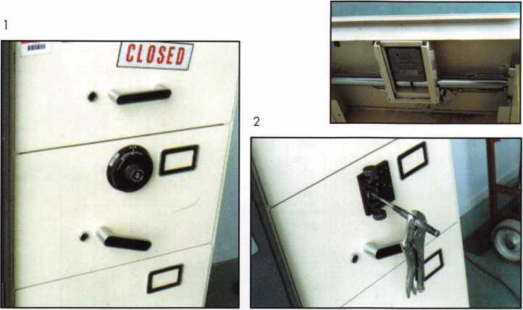

4

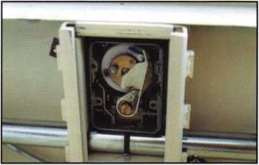

Art Metal, U.S.A.

The first container to look at is an Art Metal file safe recently opened. This safe and a Mosler Class 6 black label had lost combinations. I chose to pull the dial and drill a scope hole to open this safe. I started by drilling most of the spindle away and using a pair of locking pliers to break it off. This left some material to grab with a small tool to turn the spindle. The lock is mounted vertical down, so the template is mounted pointing down. I drilled the outer skin with a 9/32" high-speed steel drill to allow some clearance. Next chucking up a 1/4” StrongArm bit, I expected to be into the lock case within a few minutes. This was not the case. Art Metal provided a pretty good hardplate. The first bit barely scratched the surface. I punched the surface of the hole and chucked up a second bit. After a couple more drill and punch attacks, I was able to get a little bit deeper into the hardplate.

The box appeared to be case hardened. It took six or seven drill bits to get through the hardplate. Drilling a second unit a couple of weeks later showed the same result. Extremely hard on the surface, a little easier drilling through the center and hard on the inside of the box. Once inside, there is about a 3/16" gap between the lock box and the lock. I drilled into the lock body with a high-speed steel bit and used a scope to line up the wheels. Next, the drive cam must be rotated to a point where the opening is lined up under the fence and the spindle must be pushed in to fire the accelerator spring. With a dial intact (this is at "o"

if the dial is pulled), you need to experiment to find the right location. You can also determine the correct location by looking at the spline or slot on the spin­dle. Place the spline slots at approximately 18 and 68, and push in; if this doesn't work, try turning the spin­dle 50 numbers and try again. One of the two posi­tions should be the correct location. If the drive cam is not properly aligned when the accelerator spring is fired, a second "S" spring will reposition the lever off the wheel pack. Depending on the hole location, it also possible to gently pry the fence into the wheel pack. After finding the correct location and pushing the spindle in, I got a little surprise. My pounding on the safe or possibly before I started, two screws had come loose. One was now blocking the accelerator spring preventing bolt retraction. I spent some time probing and moving the screw before the bolt finally retracted. Once the safe was open, the customer cleaned out the contents.

The second safe to open on this trip was a Mosler black label. The label on this safe was missing, but based on the Mosler MR302 lock, it was a good bet it was a black label. Mosler MR302 locks lost their approval for use on government containers on May 16, 1989. This was well before red label containers were produced. This same date LaGard also lost their approval for the 1980 lock. The reason for the loss was because of how the locks operate. They are both considered single function (dialing back to the right

Keynotes • April 2003



5

Hamilton

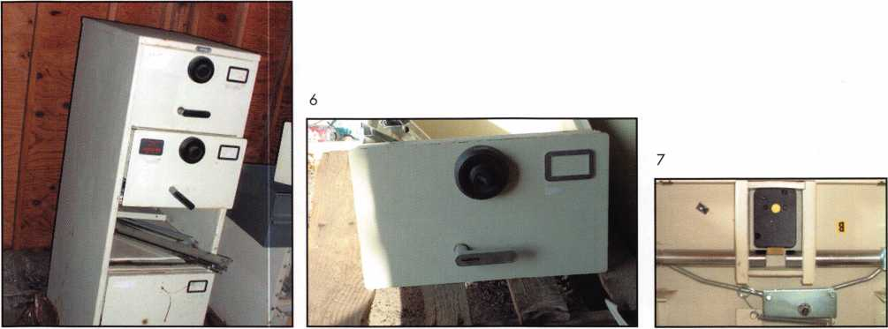

after dialing the correct combination retracts the bolt. The reason both locks lost their approval is because of the development of an autodialer. A single function lock could now be opened with an auto dialer, and though it takes some time, the locks could be opened surreptitiously. The only locks left approved for use were manufactured by S&G until March 12, 1992 when the Mas-Hamilton X-07 was approved and all mechanical locks (with a few excep­tions) were no longer approved. Both the 8400 and 8500 series locks required a dual motion to retract the bolt. The 8400 series has a second turn knob in the center of the dial; turning back to zero, it is turned, opening the drive cam and allowing the fence to drop into the wheel pack, and the dial is again turned right to retract the bolt. The 8500 series is the push-in style described above. Coming back to zero, the dial is pushed in and the accelerator springs fire the fence into the wheel pack. Then, once again, the dial is turned to right to retract the bolt.

The second safe opening was uneventful; the lock is again mounted vertical down. I pulled the dial, drilled a scope hole, lined the wheels up and had this safe open in about 10 minutes. The customer mentioned he was taking them out to scrap, so for a small reduc­tion in the opening fee, we now have two file cabinets for use in our shop. The reason for using both in our shop is the lack of a label on the Mosler, and I would rather retire the Art Metal than try and resell it for storage of classified materials.

The last safe to discuss this time is the Hamilton file safe. It looks a lot like the Art Metal cabinet, mainly because in 1988, Hamilton purchased the tooling of the now disapproved Art Metal company The compa­ny was founded around 1986 or 1987 by Len Wetz, a former executive of both Art Metal and Mosler.

They corrected the problem with the Art Metal design that caused them to lose the approval and started producing safes. Again the lock is mounted vertical down. A good general rule in GSA containers is to remember the lock bolt points towards the han­dle. The only Hamilton black label containers I’ve encountered were very tough to drill. I used a dia­mond core drill just like it was a red label. I'm not sure if all Hamilton black labels used the same hard- plate or if they switched to the red label plate early.

Both Mosler and Hamilton produce (or produced) red label containers. I understand the red label construc­tion requirement came in just prior to the require­ment for Mas-Hamilton X-07 locks. If you are going to open a red label, either bring some diamond core drills and a fixed drill rig like the StrongArm Mini rig or the bullet rig from Lockmasters. Or, bring your lunch and dinner, because you will be there for quite a while. I've had luck at times with carbide drilling some portion of the hole, but never all the way. I’m sure if you wanted to try it could be done, but why? After the first time, I used a diamond core drill; it now takes around an hour to get a hole into the lock case. Besides drilling a small hole to open a container,



Keynotes • April 2003

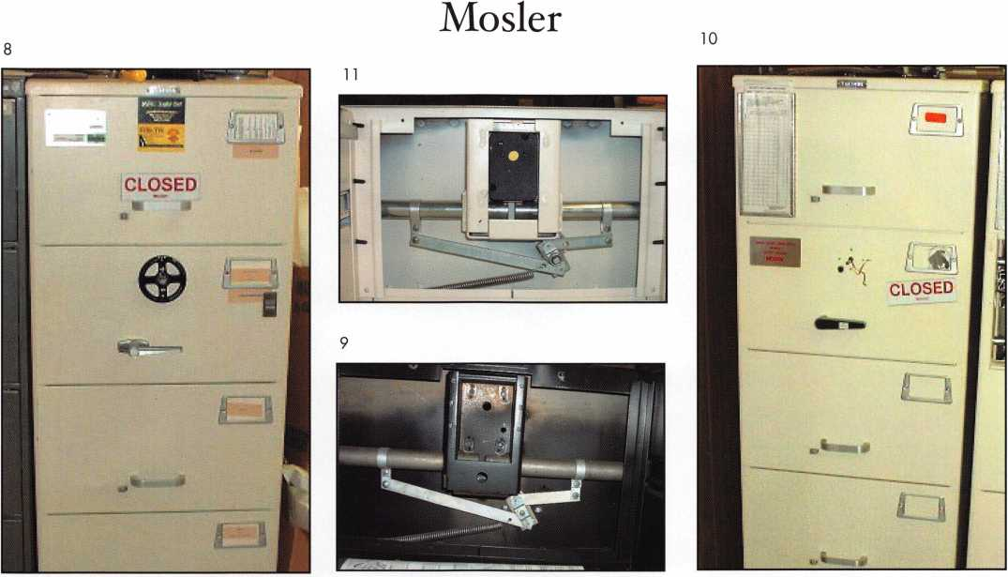

GSA allows the use of hole saws to cut the bolts of class 6 red label containers. This requires carbide- tipped hole saws to get through the hardened bolts. After using this method for a couple of years, I now reserve it as a last resort. First the drawer head must either be replaced, or it must be sent to the DOD lock program office for repair. In other words, it is not repairable in the field. A different method is used to open class 5 containers. The GSA approved method of opening them is to use an abrasive carbide saw blade in a circular saw. Very messy and again, the drawer head must be replaced. Second reason is both these options are rather crude. Stick with drilling a small hole under the dial ring.

The method of repairing a hole on a GSA container is specified by GSA. You can find the complete informa­tion on the web listed above. Red and black label safes have different repair requirements with the red label having more stringent rules. If you always follow the rules for a red label you will exceed what is need­ed for the black label. The basic requirements are as

follows. First the hole must be placed under the dial ring. The hole can be any size so long as the repair is done with a carbide pin driven into the hole and welded. Commercially available carbide pins are pro­duced in 1/4" from Lockmasters and Northwest Safe and Vault is now producing pins in both 1/4" and 5/16". If you want to drill a different size hole, you must produce you own repair pin. After the pin is welded in place, the safe face under the dial ring must be puttied, textured and painted. The repair must not be visible to the naked eye. A new lock must be installed and an invoice written.

GSA containers (in general) are not much different than TL-rated commercial safes in terms of difficulty to work on or open. They seldom have external relocks, but all should have hardened lock boxes around the lock to prevent punching and prevent scoping the change keyhole. The most difficult part of the job is making sure you understand and follow the rules or you potentially could void the GSA approval, rendering the safe useless for the customer.

Keynotes • April 2003

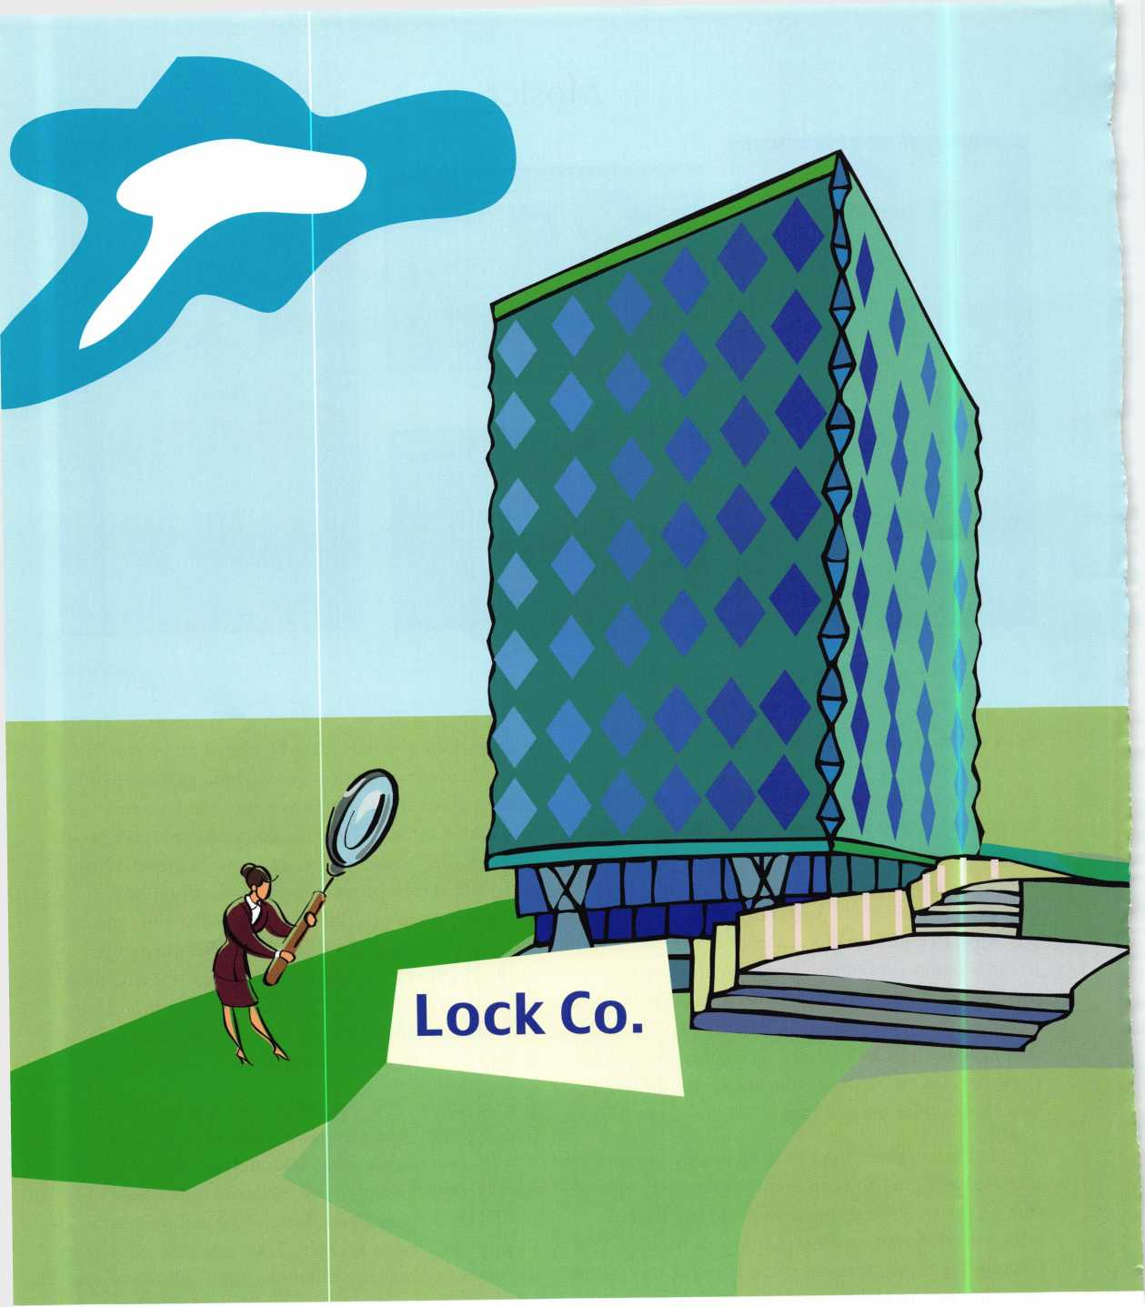

32

Keynotes • April 2003



Know Your Employer

By John C. Elliott Jr. CML CPS

Over the years, it would seem we as professional busi­nessmen and women have placed a lot of attention on new employees as to their prior work record, abilities, and in some cases, criminal records. With the many layoffs that are happening around the country right now, we are spending more time calling and reviewing each new application, enabling us to hire the best per­son for the job in our industry. Each employee often­times can and will specialize in certain areas of the lock and safe industry; thus, we will hire accordingly Many times we enlist the services of someone to do a complete background check on our prospective employees as we find our companies are involved in sensitive areas of both commercial and government clientele. We find ourselves working in financial insti­tutions and in government offices; thus, we want to be sure these folks have a good record of accomplish­ment and will keep our company’s good name, A GOOD COMPANY NAME.

Unfortunately, for those of us who are the backbone to each company, both large and small, we have failed. We have failed to check out the companies that we desire to work for or even the ones where we are cur­rently working. We forget that, sometimes, a compa­ny that has been in business for, lets say 60, 70 or 80 years -- or even 20 to 30 years — might not be the best company in which to work. Just because it might be still under the original name and handed down to the sons and grandsons, it could have problems. Even if it is a young company, there might be hidden problems. We fail to ask around to other people in the industry or to the lock suppliers as to the company’s ability to keep their employees, or ask if they pay their bills on time. Do they pay their sales taxes on time, do they

have current or past judgments against them? Do they pay the vendors they might contract to do work for them in others parts of the state or in other states on time? We should ask current employees, who might be able to talk away from the business, questions per­taining to paychecks, are they on time, are they asked to hold them or have they had problems cashing them at the bank where they are drawn? Do we ask our prospective employers for references, if we are responding to an ad they have placed in a newspaper or trade journal; it should not offend them to provide this information? In larger cities, some things can be hidden and hopefully forgotten, as the employee turn over might be high or they would hope that in time any known problems would just disappear.

In many cases, as we do not have laws pertaining to the locksmith businesses (at least in Georgia we do not), anyone can pay the fee, hang a shingle and become a locksmith or start a company. The owners could have police records, and in some cases, may have been in prison or jail for such things as child molestation, horse theft and even theft of money from adult bookstore vending machines. While the information some might think would be confidential, it can be obtained without too much difficulty, as it becomes a public record and is kept in courthouses all over the country. It only takes a few minutes to do some calling around or a visit to the county court­house. If you feel that you cannot take the time or that you are unsure just how to obtain this informa­tion, many companies are listed in the yellow pages that can and will do a check for you on the business in question. If you have access to the Internet, you can do a small inquiry or do a complete company



Keynotes • April 2003

background check with many providers for a very rea­sonable fee, anywhere from $3 (Business Credit USA) to several hundred dollars; this depends on just how much information is desired. You can and will find out a lot of information on the owners, officers (if it is a corporation), and its credit listing on how they pay their bills, their physical location and any other cor­porate listing addresses, if they have filed for bank­ruptcy at any time in the past, and see any judgments that may have been filed against the company or the officers. This is much different from doing a credit check on an individual, and is very easy to obtain. KnowX.com is another good informational source and provides credit information on both companies as well as individuals. While I have listed these two in this article, I must say there are many others you may choose to use. I have, however, used these companies before with great success.

Providing for our families is very important. We need to be sure if we choose to work for someone that both you and your employer are very happy, as you both will be providing a service to each other. If you make any agreements, it must be put into writing. Whether it is from someone in the family business where you are working, or for another business large or small, from a manager or owner, it is just plain good business to put it in writing, so you will not have any problems later when it comes time to make good on the agreement or move away, or leave for any rea­son, if it is not in black and white and on paper, you will be stuck in the old loop of "he said, she said," and in some cases, the employer will want to (illegally) keep your last paycheck to cover any expenses they claim you owe.

If there is more than one person involved with any decision making in the organization, they should all sign any pre-employment agreements, (i.e., will you run after-hours service calls, will you be salaried, and

if so how many hours will you be expected to work, if hourly what is your rate of pay, if commission what is the breakdown on base salary, how will raises be given, will they pay for any moving expenses if appli­cable, will they pay for part of or any of your contin­ued education in the lock industry, is there any retire­ment benefits, will they furnish a van for you to take home even if you do not run after hour calls; if you are hired on as a manager or you are promoted later, what can you expect from the company and what will be expected of you, uniforms, shoes and tools, etc. The list can go on and on.

Remember you should always sit and talk to your employer or manager even after you are hired. Things do come up so be sure to have a good relationship with him or her. This just keeps everyone one the same page using the same rules.

While the ideas and thoughts I have shown in this article might seem to be very elementary, it is some­thing we do consider long after we have been down the road of hard knocks. Promises made and never kept. If you find yourself in the job market, look at everything, from the neighborhood, the clientele, and the business as a whole, not just the fact they are looking for a warm body to fill in a gap.

You see, we can safely say from what has been written in this article, some of us have ... been there, done that. We have, during the many years of our lock­smith careers, had firsthand knowledge of, or have worked for, companies with these problems. You would think we would have learned after the first or second time; however, we are at times just blind to the facts, or we think that it is something that will not happen again as we are by nature very forgiving.

It only takes a little time to save everyone a lot of heartache and bad feelings, so I say, "Know Your Employer."



Keynotes • April 2003

**For Chapters and  
Affiliates Who  
Recruit!**

If your chapter gets 15 new members: ALOA will send instructors out to your site for two free days of ACE classes FREE OF CHARGE! Plus, the chap­ter or affiliate that recruits the most new members gets three free convention packages for our blowout show in sparkling Las Vegas in July of 2003!

Don't pass up this fantas­tic chance for these gt>at free giveaways, an expanded group of peers with whom to learn and grow, and the same fantastic education, protection and promotion ALOA has been providing for our great profession for almost 50 years! Call us today at 800/532-ALOA (2562) for more informa­tion, or visit us on the web at [www.aloa.org](http://www.aloa.org).

tubers ft,

Ultt*ew ^

ALOA Membership. Prove You’re a Pro

[Pick Up Some Players!

Attention Current Members! As the best security pros in the world, you play a vital role in making ALOA what it is. You make our industry hym, and we're going to prove it this year by offering you more benefits than ever. For the entire calendar year of 2003, those who recruit new members will receive special gifts from ALOA. We're asking you to prove you're a pro by sup­porting the only professional organization that exists to help educate, protect and promote security profession­als in America and beyond. Here are some of the details of our campaign:

**For New Members!**

All newly recruited members receive a useful ALOA 11-piece pick set from LAB, plus our stirring "ALOA Locksmiths Secure America" decal for the shop or van.

**For Current Members Who Recruit!**

1 new member: The useful ALOA 11-piece pick set from LAB.

5 new members: A handsome ALOA Polo Shirt (w/ stitched logo)

10 new members: LAB's great Schlage/Kwikset Combination pin kit -- plus membership in the ALOA President's Club, with your choice of a dazzling ALOA ring or a classic ALOA blazer (plus a periodic listing in Keynotes).

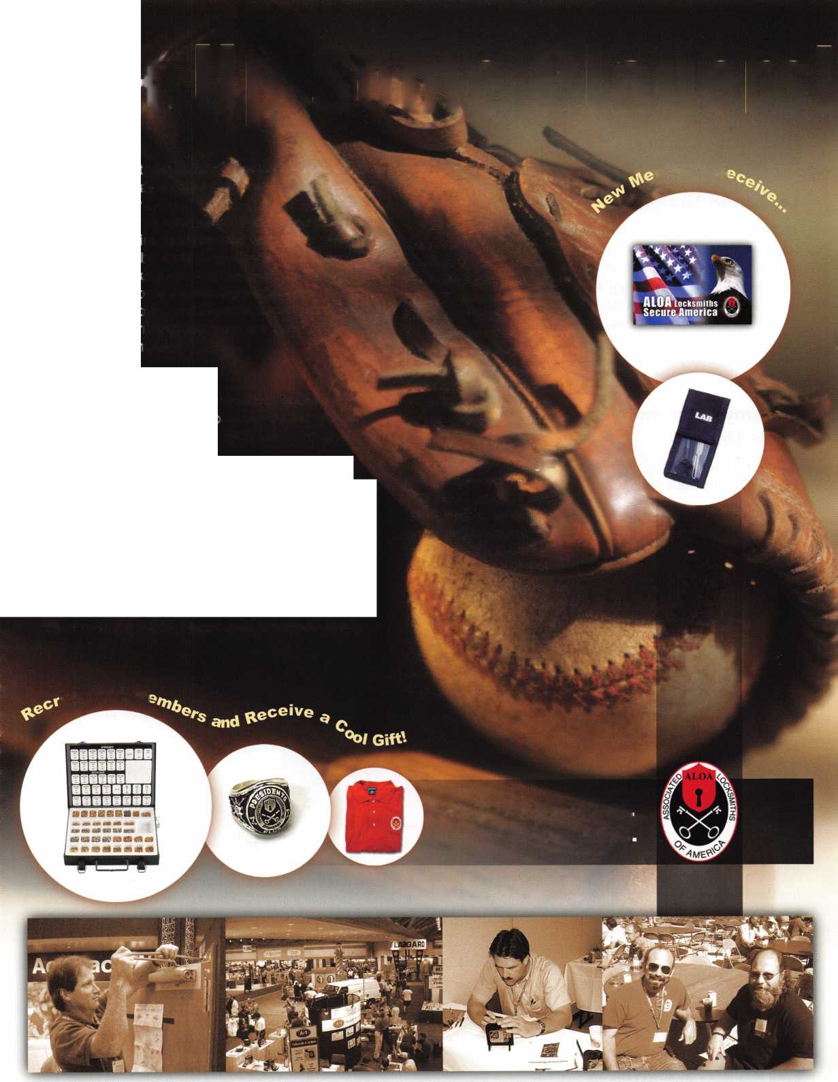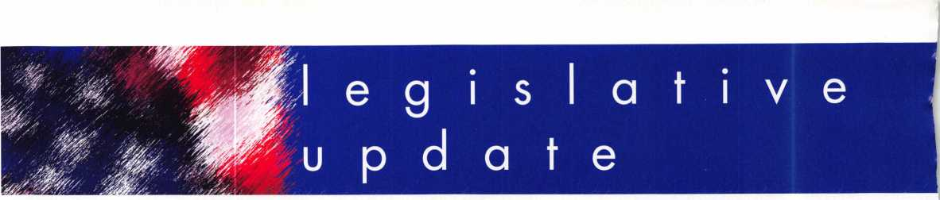

Louisiana Licensing

ALOA's Director of Public Policy, Tim McMullen attended the Louisiana Burglar and Fire Alarm Association (LBFAA) meet­ing along with Jim Queen, CML and James Portie, CRL, President of Lou-Miss Locksmith Association. Jim is the lock­smith designee to the LBFAA Board of Directors. They are willing to work with locksmiths on an update to the alarm licensing law that will include locksmiths. They have indi­cated that any definition of locksmith will include access control and CCTV.

National Automotive Services Task Force Update

ALOA's Director of Public Policy, Tim McMullen and North Central Director Mark Blum, CML, CPS recently attended the National Automotive Services Task Force (NASTF) meet­ing in Detroit, Michigan. The purpose of the meeting for ALOA was to ask that "non-emission information that is needed to originate a key using scan tools" be added to the NASTF service matrix so that locksmiths may send in complaint forms when they do not get this information from manufacturers (which is most of the time). Each manufactur­er who gave a report on the current situation with their serv­ice information websites noted that the average daily fee is around $20. They are currently working on another layer of the matrix for reprogramming information that would include immobilizer information. However, when it came to including the information we are looking for, Toyota,

Ford and others were adamantly against putting manufac­turers who would allow such information on the NASTF website for fear it would advertise "who can steal a car" (Toyota) and "give insurance companies a reason to charge higher rates for those cars" (Ford). The suggestion was made that the first step be to assess which OEM's are, or willing to make available to locksmiths, the information to originate keys using scan tools. In the meantime, we have transferred complaints that we have gotten with the ALOA Complaint form to the NASTF complaint form and sent them in to the appropriate NASTF contact.

Aftermarket Summit Update

ALOA's Director of Public Policy, Tim McMullen attended the  
Aftermarket Legislative Summit along with Maryland  
Locksmith Association President, Lance Edwards and  
Locksmith Association of DC President Jim Mullins, CPL.

They assisted the aftermarket in supporting the re-introduc-  
tion of the "Motor Vehicle Owners' Right to Repair Act" and  
spoke to the Senators and over a dozen Representatives  
from Maryland and Texas. They passed out a handout  
entitled, "Why Locksmiths Support the Motor Vehicle  
Owners' Right to Repair Act" which included stories from  
locksmiths and how their customers had been inconve-  
nienced because they were unable to service the customer's  
car. In between meetings, Tim visited about 25 of last  
year's co-sponsors' and also gave them a handout.

Congress now understands the issue for locksmiths and why  
we feel this legislation is important not only to our profes-  
sion, but to the consumer as well.

JOIN THE LEGISLATIVE ACTION  
NETWORK TODAY!

As we continue to expand our  
resources and become more com-  
petitive in the legislative arena, we  
need the monetary resources to  
match our successes. You can help  
with as little as $24.95 to the  
Legislative Fund. This is only the  
minimum that we are asking, and  
encourage you to give more if you  
can. Those that contribute will be  
given a Legislative Action Network

Member kit to use in their grass roots efforts. Members  
who donate $100 or more become Legislative Action  
Network Council members, and enjoy the following extra  
benefits: a reserved place of distinction on the special LAN  
Council; Discounts on ALOA bookstore items; 10 % rebate  
on all ACE classes; Complimentary Legislative Convention  
merchandise. Join today online at  
[www.aloa.org/news/lan.htm](http://www.aloa.org/news/lan.htm).



Keynotes • April 2003

CONNECTICUT SB 14

SUMMARY: Requires the licensing of locksmiths.

STATUS: 01/08/2003 INTRODUCED and Referred to General

Laws Committee

The text of the bill has not been released from legislative serv­ices, but has been assigned a bill number.

ILLINOIS SB384

SUMMARY: Amends the Regulatory Sunset Act. Extends the repeal of the Private Detective, Private Alarm, Private Security, and Locksmith Act of 1993 to January 1, 2014.

STATUS: 02/19/2003 Introduced and sent to Senate Committee

on Licensed Activities

MINNESOTA HB773

SUMMARY: Requires that employees of electronic security system compa­nies, undergo criminal history background checks.

STATUS: 03/06/2003 Introduced and sent to House Committee on

Judiciary Policy and Finance

There is licensing for alarm and security system companies currently in the Code, but no definition of what constitutes an electronic security system. This bill defines it as "an assembly of electronic equipment and devices that provides as its main purpose the protection of life or property, and the detection of threats or violations to the security of the protected premises, including, but not limited to, solely or in combination, the fol­lowing systems functions: burglary detection, access control, or closed circuit television." Although this definition is in the Criminal Code, it could be used in the Licensing portion of the Code.

MISSISSIPPI SB2367

SUMMARY: Burglar alarms; license and regulate installation.

STATUS: 02/04/2003 Died in Committee.

The definition of Burglar Alarm reads, "a security system com­prised of an interconnected series of alarm devices or compo­nents, including systems interconnected with radio frequency signals, which emits an audible, visual or electronic signal indicating an alarm condition and providing a warning of intrusion which is sent to a central station and requires a response by an emergency team such as police or fire personnel.

MISSOURI SB680

SUMMARY: Establishes a licensing board to regulate electrical contrac­tors.

STATUS: 02/27/2003 Introduced

03/1 1 /2003 To Senate Committee on Financial and Governmental Organizations, Veterans Affairs and Elections 03/17/2003 Hearing Scheduled

This bill includes requirements for a low voltage electrical con­tractors license with most of the requirements being supervi­sion by a licensed electrical contractor for a minimum of 12,000 hours. Although the definition does not indicate what constitutes "low voltage", the IBEW has already written the regs for this bill and defined low-voltage to include access control and CCTV. A letter from ALOA has gone to all the committee

NEVADA SB39

SUMMARY: Requires landlord to change entry locks of

dwelling unit before delivering possession of dwelling unit to new tenant.

STATUS: 02/03/2003 Introduced

02/03/2003 To Senate Committee on Judiciary

NEW YORK AB2646

SUMMARY: Establishes security requirements to be fulfilled by owners of multiple dwelling units including deadbolt locks, window pins, adequate lighting, solid core doors, intercoms and optical viewers; provides requirements for each such security meas­ure.

STATUS: 01/29/2003 INTRODUCED and Referred to Assembly

Committee on Housing.

NEW YORK AB5024

SUMMARY: Provides that class A multiple dwellings having 8 or more apartments erected or converted prior to 1 968, must have automatic self-closing and self-locking doors at every entrance from the street, roof, passageway, court yard, cellar or other entrance; excludes main entrance halls and lobbies if equipped with automatic self-locking doors.

STATUS: 02/24/2003 INTRODUCED.

02/24/2003 To ASSEMBLY Committee on HOUSING.

NORTH DAKOTA HB1159

SUMMARY: Relates to the jurisdiction of the private investigative and secu­rity board. Gives vague definition on what constitutes "securi­ty services"

STATUS: 01/07/2003 INTRODUCED and Referred to Industry,

Business and Labor Committee

01/14/2003 First Reading

SOUTH CAROLINA SB 186

SUMMARY: Provides certain instances in which dead bolt locks requiring a key for operation on both sides may be used on exit doors.

STATUS: 01/14/2003 INTRODUCED and Referred to Committee

on Judiciary

TENNESSEE HB274

SUMMARY: Relates to locksmiths.

STATUS: 02/04/2003 INTRODUCED and sent to Senate

Committee on Government Operations

TENNNSEE SB188

SUMMARY: Requires that all alarm system contractor employees who sell, install or repair alarm systems, including closed circuit televi­sion systems, shall take and successfully complete the National Burglar and Fire Alarm Association Level 1 or equiv­alent training.

STATUS: 02/06/2003 INTRODUCED

Copies of all these bills can be found  
at [www.aloa.org/news/legislation.cfm](http://www.aloa.org/news/legislation.cfm)

3

Keynotes • April 2003

ALOA Complaint Form

The proposed “The Motor Vehicle Owner’s Right to Repair Act” ensures the right of a motor vehicle owner to obtain all information required for the diagnosis, service, and repair of the motor vehicle in a timely, affordable, and reliable manner. Although the bill does not specifically say what information must be pro­vided, ALOA is working with the after-market industry to ensure that the information you need to service any vehicle is released. This complaint form provides ALOA with information that will identify any prob­lems locksmiths may encounter through servicing their customers during a vehicle lockout/re-keying/originat- ing keys incident. We will use this information to make our case to the automobile manufacturers and to Congress on why this bill is important to locksmiths.

Locksmith Name:ALOA#

Shop Name:

Date/Time Received Customer Call:

Customer Name: Phone:

Vehicle Manufacturer: Type:Year:

Briefly describe incident, of why you were unable to service the customer, including any inconvenience the customer experienced:

Return completed form by mail or fax to:

Tim McMullen, Director of Public Policy

ALOA

3003 Live Oak St.

Dallas, TX 75204 Fax: (214) 827-1810 (make copies as needed)

**RING of a KING**

|  |  |  |  |
| --- | --- | --- | --- |
| Name | Members | Kenneth E. Kim CRL, CPS | 16 |
|  | Recruited | Joseph W. Whitaker CPL | 16 |
| Kwok-kei Leung | 212 | Michael E. Jordan Jr, CML | 16 |
| Henry W. Raymond | 100 | Brian J. Reetz | 16 |
| Yuriko Yanai | 79 | Russell P. Fuller CRL | 16 |
| Mary S. Ohmit CPL | 66 | David M. Troiano | 16 |
| Charles C. Robertson CML | 65 | Robert C. Rodocker CPL | 15 |
| Jack Hobin CPL | 51 | William J. McElheney CML | 15 |
| William B. Neff CML | 48 | Jon B. Griswold CML | 15 |
| William Lee CRL | 39 | Michael D. Robinson CRL | 15 |
| C Allan Halverson | 38 | Daniel L. Landry Jr | 15 |
| Myeong-Rae Cho | 38 | Steve L. Cothron | 15 |
| Michael B. Groves | 36 | Paul M. Souber | 14 |
| Dana L. Barnum CML | 35 | James T. Brickler CRL | 14 |
| Barry K. Leas CRL | 35 | Joseph C. Fuller CML, CMST | 13 |
| Danny W. Rudd CPL | 32 | Calvin G. Harris CML | 13 |
| Larry A. Warnick CML | 31 | Peter Sarailian CRL | 13 |
| Eugene R. Altobella Sr | 31 | Frank D. Hartung CML | 13 |
| Jim Williams CRL | 31 | John W Soderland CML CMST | 13 |
| Marian M. Swann CRL | 26 | Rolando Bouza | 13 |
| Robert F. Carroll CPL | 26 | Donald H Shiles RL | 13 |
| J Thomas Hood CML | 26 | Richard C. Sievers | 13 |
| Elvis D. Hammerschmidt CPL | 24 | Raymond C. Lusk CML | 12 |
| John L. Shandy CML | 23 | John F. Engel CRL | 12 |
| Jerome L. Cohen CML | 23 | Eric F. Veal | 12 |
| Peter K. Gauthier CPL, CPS | 23 | Thomas J. Demont CML, AHC | 11 |
| Philip A. Rovenolt CPL | 23 | Basil W. Shannon CPL | 11 |
| Man-Soo Seo RL | 23 | Timothy K. Chow | 11 |
| James J. Cawby CML, CPS | 22 | Dale L. Knowles CPL | 11 |
| Robert W. Du man Sr, CML | 21 | Timothy J. Moore CRL | 11 |
| John S. Dorsey CML, CPS | 19 | James V. Hawley CRL | 11 |
| Walter W. Lascar RL | 18 | William T. Beranek | 11 |
| Keizo Takahashi CRL | 18 | Gene Eldridge CPL | 10 |
| James E. Fowler Sr, CML | 18 | Ronald P. Riggins CML | 10 |
| David C. Harris CML | 18 | Lester S. Brodsky | 10 |
| Takashi Kuwana CRL | 18 | Ralph O. Warren CML | 10 |
| Eugene R. Altobella Jr | 18 | Larry L. Votaw CML | 10 |
| Peter R. Hall | 17 | Thomas R. Smith CPL | 10 |
| Thomas G. Vandersteen CML, CPS.. 17 | | Todd K. Ladwig CML, CPS | 10 |
| James E. Gruber CRL | 17 | William T. Straub CML | 10 |
| James L. Hancock CRL | 17 | Richard T Johnson CPI | 10 |
| Ernest W. Wright | 16 | Robert M Massard CRL AHC | 10 |
| Joseph P Ferrero CML | 16 | Marian E. Sagar | 10 |
| Gary F. Teams CPL | 16 |  |  |



How can I join the President's Club?

You can earn a membership in this prestigious club by recruiting  
just 10 new members for ALOA.

*Any ALOA member may participate.

What do I get?

When you recruit 10 members, you receive a  
handsome blue blazer with a President's Club crest.  
For each additional five members you recruit, you  
receive a lapel pin with gold-filled numbers, indicating,  
your recruiting successes.

You also get the satisifaction of knowing that you are  
helping your association, helping your industry grow,  
and you are helping fellow locksmiths achieve success.

How do I get started?

Mail the form below to the ALOA office for a supply of  
applications (800) 532-ALOA or FAX (214) 827-1810.  
One President's Club credit is awarded for each new  
applicant. Credit is awarded only after the membership  
application is pproved. However, the credit will apply  
for the period in which the application is received.  
Failure to identify yourself as the sponsor on the applica-  
tion form at the time it is submitted to ALOA for process-  
ing will forfeit any credit.

o^cr.

|  |  |
| --- | --- |
|  | Yes! 1 want to join the ALOA President's Club. |
|  | Please rush me applications so 1 can start earning credit toward membership in the club! |
| Name | |
| Company | |
| Address | |
| City | State Zip |

Mail this form to ALOA • 3003 Live Oak • Dallas, Texas 75204-6186



EMPLOYMENT

LOCKSMITH/BUSINESS PARTNER

Growing locksmith company in Edmonton, Alberta, Canada (and surrounding area) requires a locksmith/business partner. We are looking for a hard working, dedicated individual with a desire to further his/her career. Please send or fax your resume to:

Robert Richard • Knight Lock and Safe • Box 21043 Leduc, Alberta T9E 6R4 • Fax (780) 980-8283 e-mail: [knightlocksnsafe@aol.com](mailto:knightlocksnsafe@aol.com)

LOCKSMITH WANTED

NW Pennsylvania. Rapidly growing company. New retail store. Looking for locksmith for outside service. Mostly commer­cial work. Safe servicing and access control experience a plus. If you enjoy outdoor sports of all kinds, including hunting and fishing, this is the place to live. Contact: Uhlig Lock and Safe

16325 Conneaut Lake Rd.

Meadville, PA 16335

814/724-2255 • (814) 724-1687 (fax)

[lockdoctor@alltell.net](mailto:lockdoctor@alltell.net)

STOP LOOKING!!!!! EXPERIENCED TECHNI­CIANS WANTED

Lock into your future now! If you are experienced, intelligent, and desire a secure future, come join our team. We are a full service commercial/residential security service (locks,keys,safes,cctv,access control, door related hardware). We offer: sign on bonus, top wages, company vehicle, 401k, paid vacation, paid holidays, new uniforms, cross training, and job satisfaction. We are looking for the best tech's, who are ready to be treated and compensated as professionals. Bass Security Services, Inc. • Ph#216-755-1200 ex.#128 • Fax#216-755-1220 • E-MAIL/ [rmesnick@bass-security.com](mailto:rmesnick@bass-security.com)

LOCKSMITH WANTED

Busy shop in Woburn, MA, has immediate opening for a self- motivated, ambitious locksmiths. We have a large customer database for automotive, AAA, commercial and residential accounts. Applicants with own van and tools are guaranteed 50 percent commission. We supply more expensive tools, such as TCL, NGS, other transponder programming tools, etc. No waiting to get paid, no having to be available 24 hours a day to make a good week's pay, and no worrying about the enor­mous bills associated with being self-employed. (Yellow pages, direct mail, answering services, pagers, office supplies, office payroll, rent, heat, electric, and other bills that can add up to more than your gross!) If you feel you're a great locksmith and want to be rewarded for your experience, this is for you. If

you currently own your own business now and don't want all the headaches of being in charge of advertising, human resources, customer relations, payroll, accounts, receivable, accounts payable, dispatch, etc., let us know if you want to be a partner. Too many great locksmiths go out of business for try­ing to do it all. If you feel this is an opportunity you would like to know more about, send resume to:

Locks & Keys, Inc. • P.O. Box 222 • Woburn, MA 01 801 Or call John at (781) 933-9999

ACCOUNT EXECUTIVE WANTED

We are seeking an energetic, experienced sales professional to join our rapidly growing team. Candidate must possess a strong background in commercial hardware as well as elec­tronic access control, (cctv and alarm experience is a plus!). Minimum 5 years sales experience required. We offer: Top wages, commission, expense account, 401k, paid vacations and holiday, hospitalization.

E-MAIL resume to: [rmesnick@bass-security.com](mailto:rmesnick@bass-security.com) or phone-216- 755-1200 ext# 128.

AUTOMOTIVE LOCKSMITH WANTED

Relocate to South Florida and throw away your deadbolts and three keys for a dollar.

We run over 300 calls per week. You must own a truck with tools and code equipment to cut all foreign and domestic keys. You can earn $800 to $1500 per week. South Florida Lock and Safe. 800/928-2926. Please if no truck or tools, no calls.

LOCKSMITH WANTED FOR S. ORANGE COUNTY.

Experienced in all areas including access control and safes. Permanent position with excellent compensation and benefits including bonus, overtime, health plan, retirement plan, sick leave, paid vacation and holidays. Van and tools provided. Call 949.492.5700 or fax resume to 949.492.0246. TONY's LOCKSMITH AND SAFE SERVICE • 217 South de la Estrella • San Clemente, CA 92672

HELP WANTED

Argens, Inc., a 123-year-old security company located in Seattle, is seeking applications for two positions. Jorneyman locksmith with expert hardware installation skills. Must be able to perform all facets of hardware installation and the ability to improvise when required. Also Journeyman Dispatcher must have experience in all facetss of locksmithing and installation. Excellent pay, benefits and IRA. Fax resume to 206-622-5056 attn. Steve T.

SUPERVISOR, SECURITY SYSTEMS

Emory is one of the five largest private employers in the Atlanta metro area and the largest employer in Dekalb County. The University is admired worldwide for academic, patient care, research and technological excellence. As an Emory employee, you are part of a community which values diversity, education, training, and personal development. Creativity and innovative ideas are nourished and rewarded. We invite you to share in a unique culture of education, research and health care.

We currently have a great opportunity for a Supervisor, Security Systems in our Security Shop. They will Provide lock­smith, alarms, control systems and security system services including installing, repairing, inspecting, and recombination mechanical, electro-mechanical, electronic locking and moni­toring devices and door hardware. Performs diagnostic tests on digital, key pad and card-locking, and other electronic locking systems for the University.

MINIMUM QUALIFICATIONS: High school diploma or equiv­alent. Five years combination locksmith and electronics/securi- ty systems experience, including two years supervisor experi­ence. Thorough journeyman level knowledge and skills in mechanical, electro-mechanical, electronic locking and moni­toring devices and door hardware. Journeyman level skill in maintenance and repair procedures including preventive main­tenance, breakdown repair and troubleshooting, construction, installation and fabrication techniques typical in trade; perform mathematical computations of trade. Knowledge of ADA specifications and proper use and maintenance of hand and power tools, test equipment and electronics equipment related to job functions. Valid Georgia driver's license and insurable driving record. Some positions within this classification may require the ability to lift 50 pounds and to bend, stoop and twist.

Departmental Information/Preferred Qualifications: Ideal can­didate will have a high degree of organizational, communica­tion, customer service, and good leadership skills.

We offer competitive salaries and world-class benefits includ­ing major medical/dental/vision/life insurance, disability insurance, paid holidays/vacation, tuition assistance, a gener­ous employer matching 403(b) retirement plan and courtesy scholarships for family members and same-sex domestic part­ners. For more information about our benefits, please visit our website at: <http://emory.hr.emory.edu/benefits.nsf>

A career with Emory University affords a level of prestige and stability not found in many Atlanta Employers of Choice. We invite you to become a part of the Origins of Excellence!

Please submit your resume via (online from) the Emory Careers Website at emory.hr.emory.edu/careers.nsf or by mail at Emory University, 1762 Clifton Road, Atlanta, GA, 30322. Phone: 404.727.7611 Fax: 404.727.1922 Please reference Job posting 136542 when applying.

Emory University is an AA/EOE Employer

Classified Advertising Policy

Classified advertising space is provided free of charge to ALOA members, and for a fee of $.60 per word, $ 15 minimum for non-members. Classified ads may be used to advertise used  
merchandise and overstocked items for sale, "wanted to buy" items, business opportunities, employment opportunities/positions wanted and the like. Members or non-members wishing to  
advertise services or new merchandise for sale may purchase a "Commercial Classified Ad," for a fee of $1.30 per word, with a minimum of $40. Each ad will run for two issues. For  
blind boxes there is a $5 charge to members and non-members. All ads must be submitted in writing to the ALOA office by the fifteenth of the month, two months prior to issue date. Send  
to Keynotes Classifieds, 3003 Live Oak St., Dallas TX 75204-6186. ALOA reserves the right to refuse any classified advertisement that it deems inappropriate according to the stated pur-  
pose of the classified advertising section.



Keynotes • April 2003

BUSINESS FOR SALE

BUSINESS FOR SALE

Locksmith glass and screen business located in fast growing NW Arizona between Kingman, AZ, and Laughlin, NV. Well- equipped 1995 Dodge van and leased shop on busy high­way. All equipment and inventory included. $48,900 takes all. Health demands retirement. Call (928) 565-2294 or e-mail at [lmburks@ctaz.com](mailto:lmburks@ctaz.com).

WANTED TO BUY/SELL

BACK ISSUES!

FOR SALE: Assorted Issues of locksmithing

publications including Keynotes, Locksmith Ledger, The

National Locksmith, Reeds, etc. dating from

the early 1980s. Contact Richard at 281-931-7525 to make

offer.

DISTRIBUTOR WANTED

Veteran manufacturer (since 1935) of security products for vehicle protection against theft is looking for agents and dis­tributors of our products. We manufacture mechanical parking posts, steel barriers and "Denver boots" (wheel clamping against theft devices). Please contact Kantero Israel:

Fax 972-3-6837228, or e-mail: i.k.a.@hotmail.co.il

WHOLESALE SAFE DEPOSIT LOCKS

Allied, Diebold, Herrin, Hall & Mavin, llco, Lefabure, Mosler, Precission, S&G, Security Corp., Yale. Locks from early 1900s to current. Call or email for lock type and pricing sheet. Quantity discounts. Call WBI (888)329-7265 or (954)484-2404 or [sales@wbi.us](mailto:sales@wbi.us)

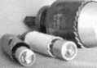

Hole Saw • Alignment Guides

No More Plywood, "C" Clamps, or ***Jigs***Needed to Over Bore Existing ***Holes***

* Our Guides let you over bore existing holes that meas. 5/8”, 3/4” & 1-1/2" diameter
* They work on wood as well as metal
* TWo small sizes ideal for desks and cabinets
* Purchase in sets or individually
* Visa, MC, Amex, Discover
* MONEY-BACK GUARANTEE

**Tri-City Lock Company**

Daniel D. Mello, Owner-Locksmith  
Groveland, CA

209 962 4692 • 209 962 4910 FAX E-mail: [slmello@mlode.com](mailto:slmello@mlode.com) **[www.tricitylock.com](http://www.tricitylock.com)**

LIQUIDATION SALE!

By appointment only. After 55 years of doing business, A- Armitage Locksmiths is closing its doors! Merchandise, lock supplies, key machines and much more! Most items are being offered 30 percent below wholesale prices! All sales final. Please bring a copy of your Illinois tax exempt registration to purchase the goods.

Weekday appointments call (773) 339-4535 Weekend appointments call (815) 238-0800

FOR SALE

Framon Tool Key Machine, 110-volt and 12 volt motor, good condition, hardly used. $1 300 plus shipping. Call Curt at 808/696-9421 for further details.

ITEMS FOR SALE

Locksmith items left over from closed business. Will sell at rea­sonable price. Must sell, have no room to store. Most keys are of older years, eg H50, H51, XI21, X39 and so on. Several thousand keyblanks, ranging from A to Z. Several boxes of automotive locks of all sorts. Several Weiser Crown and other knobs and deadbolts. Several pinning kits of all kinds. Three Gardall safes, no combos have been changed, two 1812 rotary hoppers and one double door rotary hopper. Everything at real good prices. Call Ron at 817/346-1286, or write to 6520 Andora Ave., Ft. Worth, TX, 76133. For a list of key- blanks and other material. Or e-mail: [rgdretusaf20@aol.com](mailto:rgdretusaf20@aol.com).

e

**Colorado Security Professionals Education Conference**

April 24, 25, 26, 2003

Brought to you by the following:

Central & Southern Colorado Locksmith Association • Rocky Mountain Locksmith Association Colorado Burglar & Fire Alarm Association • ALOA Front Range Chapter

Thursday, April 24, 2003

4 Basic Locksmithing (Day 1 of 2) 4 Masterkeying 4 Jail and Prison Locks • Access Control (Day 1 of 2)

Evening:

Free Dinner Buffet  
and Trade Show

Drawing for a  
Free Convention Package  
at ALOA Las Vegas

and Prizes 6pm to 10pm!

Friday, April 25, 2003

4 Basic Locksmithing (Day 2 of 2) 4 Small Format IC core (PRP)

4 Safe Lock Service & Troubleshooting (PRP)

• Access Control (Day 2 of 2)

Evening:

Fun Night Out!

Bus trip to

Colorado Central Station  
Casino Blackhawk  
One of Colorado's  
Oldest Mining Towns

Only $10.00!

Saturday, April 26, 2003

4 Large Format IC Core (PRP)

4 Servicing Aluminum Storefront Doors 4 Electronic Safe Lock Service • Life Safety Codes

Evening:

Free Labor Saver Class  
ALOA PRP Testing

Gordon Racine, CML 719-384-4707  
Barry Meyer, CRL 303-688-4104

LOCATION: Radisson Stapleton Plaza • 3333 Quebec Street • Denver CO 80207  
HOTEL RESERVATIONS: Local: 303-321-3500 • National: 800-333-3333

Please thank and support these generous show sponsors: IR Security & Safety, Intermountain Lock and Supply Co., Clark Security Products,

International Distribution Network, Access Hardware Supply, ASSA

4 = ALOA ACE Education • = NBFAA Education

**For more show information go to: [www.Radisson.com/SecurityEducationWeekend](http://www.Radisson.com/SecurityEducationWeekend)**

**or email [racine@rural-com.com](mailto:racine@rural-com.com) or [Acomal@Qwest.net](mailto:Acomal@Qwest.net)**



Keynotes • April 2003



**associate**

**members**

Distributor

ADI Inc

Phone: 631-692-1000 Fax: 631-692-3011

Accredited Lock Supply Co.

Phone: 201-865-5015 Fax: 201-865-0030 [www.acclock.com](http://www.acclock.com)

Ace Lock & Security Supply

Phone: 908-688-7666 Fax: 908-688-2442 [www.acelock.com](http://www.acelock.com)

Action Hardware Inc.

Phone: 800-662-6695 Fax: 800-930-2329

Andrews Wholesale Lock Supply

Phone: 717-272-7422 Fax: 717-274-8659 [www.andrewslock.com](http://www.andrewslock.com)

Boyle & Chase Inc.

Phone: 800-325-2530 Fax: 800-205-3500 [www.boyleandchase.com](http://www.boyleandchase.com)

Chinrose International

Phone: 503-357-7553 Fax: 503-357-5522 [www.chinrose.com](http://www.chinrose.com)

Clark Security Products

Phone: 800-854-2088 Fax: 619-974-5284 [www.clarksecurity.com](http://www.clarksecurity.com)

Cook's Building Specialties

Phone: 505-883-5701 Fax: 505-883-5704

Dire's Lock & Key Company

Phone: 303-294-0176 Fax: 303-294-0198

Direct Security Supply, Inc.

Phone: 800-252-5757 Fax: 800-452-8600

Doyle Security Products

Phone: 800-333-6953 Fax: 612-521-0166 [www.doylesecurity.com](http://www.doylesecurity.com)

Dugmore and Duncan, Inc.

Phone: 888-384-6673 Fax: 888-329-3846

E. L. Reinhardt Co., Inc.

Phone: 800-328-131 1 Fax: 651-481-0166 [www.elreinhardt.com](http://www.elreinhardt.com)

Ewert Wholesale Hardware

Phone: 800-451-0200 Fax: 708-597-0881

Fairway Supply, Inc.

Phone: 214-350-0021 Fax: 214-352-4299 [www.fairwaysupply.com](http://www.fairwaysupply.com)

Foley-Belsaw Company

Phone: 800-821-3452 Fax: 816-483-5010 [www.foley-belsaw.com](http://www.foley-belsaw.com)

Fried Brothers Inc.

Phone: 800-523-2924 Fax: 215-592-1255 [www.fbisecurity.com](http://www.fbisecurity.com)

H L Flake Co.

Phone: 800-231-4105 Fax: 713-926-3399 [www.hlflake.com](http://www.hlflake.com)

H.S. & S. Wholesale Distrib.

Phone: 313-342-6777 Fax: 313-342-7580

Hans Johnsen Company

Phone: 214-879-1550 Fax: 214-879-1530 [www.hjc.com](http://www.hjc.com)

Hardware Agencies, Ltd.

Phone: 416-462-1921 [www.hardwareagencies.com](http://www.hardwareagencies.com)

IDN Incorporated

Phone: 817-421-5470 Fax: 817-421-5468 [www.idn-inc.com](http://www.idn-inc.com)

Intermountain Lock & Supply

Phone: 800-453-5386 Fax: 801-485-7205 [www.intermountainlock.com](http://www.intermountainlock.com)

Jo Van Distributors

Phone: 416-752-2238 Fax: 416-752-7282 [www.jovanlock.com](http://www.jovanlock.com)

KeylessRide

Phone: 877-619-3136 Fax: 409-216-5058 [www.keylessride.com](http://www.keylessride.com)

Lockmasters, Inc.

Phone: 859-885-6041 Fax: 859-885-7093 [www.lockmasters.com](http://www.lockmasters.com)

Locks Company

Phone: 800-288-0801 Fax: 305-949-3619

Locksmith Ledger International

Phone: 770-886-0800 Fax: 770-889-7703 [www.lledger.com](http://www.lledger.com)

M. Zion Company

Phone: 212-349-8677 Fax: 212-964-0495 [www.mzion.com](http://www.mzion.com)

McDonald Dash Locksmith Supply

Phone: 800-238-7541 Fax: 901-366-0005 [www.mcdonalddash.com](http://www.mcdonalddash.com)

McManus Locksmith Supply, Inc.

Phone: 704-333-9112 Fax: 704-332-8664

Monaco Lock Co.

Phone: 800-526-6094 Fax: 800-845-5625 [www.monacolock.com](http://www.monacolock.com)

Omaha Wholesale Hardware

Phone: 800-238-4566 Fax: 402-444-1664 [www.omahawh.com](http://www.omahawh.com)

Phoenix Safe International LLC

Phone: 765-483-0954 Fax: 765-483-0962 [www.phoenixsafeusa.com](http://www.phoenixsafeusa.com)

Professional Business Products

Phone: 248-360-3979

Fax: 248-360-3982

[www.professionalbusinessproducts](http://www.professionalbusinessproducts).

RA-Lock Company

Phone: 972-775-6301 Fax: 972-775-6316 [www.ralock.com](http://www.ralock.com)

SecureRite.Com

Phone: 800-241-3930 Fax: 858-974-5269 [www.SecureRite.Corn](http://www.SecureRite.Corn)

Security House

Phone: 905-669-5300 Fax: 905-660-6313 [www.securityhouselock.com](http://www.securityhouselock.com)

Security Lock Distributors

Phone: 800-847-5625 Fax: 800-878-6400 [www.securadealer.com](http://www.securadealer.com)

Sentry Security Fasteners

Phone: 309-693-2800 Fax: 800-693-2872

Somerset Security Products

Phone: 800-881-5206 Fax: 800-206-9949

Southern Lock and Supply Co.

Phone: 727-541-5536 Fax: 727-544-8278 [www.southernlock.com](http://www.southernlock.com)

Stone & Berg Wholesale

Phone: 800-225-7405 Fax: 800-535-5625

The Locksmith Store Inc.

Phone: 847-364-5111 Fax: 847-364-5125 www. I oc ks m i th sto re. com

Timemaster Inc.

Phone: 859-259-1878 Fax: 859-255-0298 [www.ti](http://www.ti) me-master.com

Top Notch Distributors, Inc.

Phone: 800-233-4210 Fax: 800-854-4146 [www.4topnotch.com](http://www.4topnotch.com)

Turn 10 Wholesale

Phone: 800-848-9790 Fax: 800-391-4553

U.S. Lock Corp.

Phone: 800-925-5000 Fax: 800-338-5625 [www.uslock.com](http://www.uslock.com)

Manufacturer

A & B Safe Corporation

Phone: 800-253-1267 Fax: 856-863-1208 [www.a-bsafecorp.com](http://www.a-bsafecorp.com)

ABUS Lock Company

Phone: 800-352-2287 Fax: 602-516-9934 [www.abus.com](http://www.abus.com)

Abloy Door Security

Phone: 800-465-5761 Fax: 514-335-0430 [www.abloy.com](http://www.abloy.com)

Adams Rite Mfg Company

Phone: 800-872-3267 Fax: 800-232-7329 [www.adamsrite.com](http://www.adamsrite.com)

Adesco Safe Mfg. Company

Phone: 800-821-6803 Fax: 562-408-6427 [www.adesco.com](http://www.adesco.com)

Adrian Steel Company

Phone: 800-677-2726 Fax: 517-265-5834 [www.adriansteel](http://www.adriansteel) .com

Alarm Lock Systems Inc.

Phone: 800-252-5625 Fax: 516-789-3383 [www.alarmlock.com](http://www.alarmlock.com)

All Five Tool Company, Inc.

Phone: 860-583-1691 Fax: 860-583-4516 [www.all5tool.com](http://www.all5tool.com)

American Lock Company

Phone: 708-534-2000 Fax: 708-534-0531 [www.armericanlock.com](http://www.armericanlock.com)

American Security Products

Phone: 909-685-9680X1083 Fax: 909-685-9685 [www.amsecusa.com](http://www.amsecusa.com)

BWD Automotive

Phone: 334-872-6524 Fax: 334-874-6011 [www.bwdautomotive.com](http://www.bwdautomotive.com)

Baldwin Hardware

Phone: 610-796-4012 Fax: 610-796-4493 [www.baldwinhardware.com](http://www.baldwinhardware.com)

Be-Tech Security Systems Ltd.

Phone: 852-231-67447 www. be-tec h. com. h k

Buddy Products

Phone: 800-886-8688 Fax: 312-733-8356 [www.buddyproducts.com](http://www.buddyproducts.com)

COMPX Security Products

Phone: 864-297-6655 Fax: 864-297-9987 [www.nclnet.com](http://www.nclnet.com)

Keynotes • April 2003

**associate**

**members**

Curtis lndustries/

A Barnes Distr.

Phone: 800-555-5397 Fax: 800-867-6020 [www.curtisindustries.com](http://www.curtisindustries.com)

D&D Technologies (USA), Inc.

Phone: 714-677-1300X292 Fax: 714-677-1299 [www.ddtechusa.com](http://www.ddtechusa.com)

DETEX Corporation

Phone: 800-729-3839 Fax: 830-620-671 1 [www.detex.com](http://www.detex.com)

DORMA Architectural Hardware

Phone: 717-336-3881 Fax: 717-336-3500 [www.dorma-usa.com](http://www.dorma-usa.com)

Don-Jo Manufacturing, Inc.

Phone: 978-422-3213 Fax: 978-422-3467 [www.don-jo.com](http://www.don-jo.com)

Door Controls International

Phone: 800-742-3634 Fax: 800-742-0410 [www.doorcontrols.com](http://www.doorcontrols.com)

ESP Lock Products Inc.

Phone: 978-562-3481 Fax: 978-562-9859

FireKing Security Products

Phone: 800-457-2424 Fax: 800-896-6606 [www.fireking.com](http://www.fireking.com)

HES, Inc.

Phone: 623-582-4626 Fax: 623-582-4641 [www.hesinnovations.com](http://www.hesinnovations.com)

HPC, Inc.

Phone: 847-671-6280 Fax: 847-671-6343 [www.hpcworld.com](http://www.hpcworld.com)

Hongtai Lock Co. Ltd.

Phone: 137-238-1414 Fax: 208-793-3856

INTELUKEY Corp.

Phone: 800-226-0703 Fax: 321-724-0811 [www.intellikey.com](http://www.intellikey.com)

Jet Hardware Mfg., Co.

Phone: 718-257-9600 Fax: 718-257-0973 www. j etkeys. com

KABA High Security Locks

Phone: 860-621-3601 Fax: 860-621-9727 [www.kabausa.com](http://www.kabausa.com)

KABA ILCO Corp.

Phone: 252-446-3321 Fax: 252-446-4702 [www.kaba-ilco.com](http://www.kaba-ilco.com)

KEY-BAK/West Coast Chain Mfg.

Phone: 909-923-7800 Fax: 909-923-0024 [www.keybak.com](http://www.keybak.com)

Keri Systems Inc.

Phone: 408-451-2520 Fax: 408-441-0309 [www.kerisys.com](http://www.kerisys.com)

Knaack Manufacturing Co.

Phone: 800-456-7865 Fax: 815-459-9097 [www.weatherguard.com](http://www.weatherguard.com) LAB Security Phone: 800-243-8242 Fax: 860-583-7838 [www.labpins.com](http://www.labpins.com)

LCN Closers/Div of Ingersoll

Phone: 815-875-3311 Fax: 815-879-1497 [www.lcnclosers.com](http://www.lcnclosers.com)

La Gard Inc.

Phone: 310-325-5670 Fax: 310-325-5615 [www.lagard.com](http://www.lagard.com)

Lucky Line Products, Inc.

Phone: 858-549-6699 Fax: 858-549-3241 [www.luckyline.com](http://www.luckyline.com)

M.A.G. Security

Phone: 714-891-5100 Fax: 714-892-6845 [www.magsecurity.com](http://www.magsecurity.com)

MARKS, U.S.A.

Phone: 516-225-5400 Fax: 516-225-6136 [www.marksusa.com](http://www.marksusa.com)

MARRAY ENTERPRISES

Phone: 408-970-0213 Fax: 408-970-8767 [www.marray.com](http://www.marray.com)

MCS Communication Systems

Phone: 450-444-2040X225 Fax: 450-444-4856 [www.mcscommunication.com](http://www.mcscommunication.com)

MMD, Inc.

Phone: 865-428-3611 Fax: 865-453-4136

MUL-T-LOCK USA, Inc.

Phone: 800-562-3511 Fax: 973-778-4007 [www.mul-t-lock.com](http://www.mul-t-lock.com)

Master Lock Company

Phone: 414-444-2800 Fax:414-444-0322 [www.masterlock.com](http://www.masterlock.com)

Medeco Security Locks

Phone: 540-380-5000 Fax: 540-380-5010 [www.medeco.com](http://www.medeco.com)

NKL Industries Inc.

Phone: 800-528-9900 Fax: 757-485-0271 [www.nklindustries.com/products_NK](http://www.nklindustries.com/products_NK)

Pro Steel

Phone: 801-373-2385 Fax: 801-373-2399 [www.prosteel.us](http://www.prosteel.us)

ROFU International Corp

Phone: 800-255-7638 Fax: 253-922-1728 [www.rofu.com](http://www.rofu.com)

Rutherford Controls Int'l Co

Phone: 757-427-1230 Fax: 757-427-9549 [www.rutherfordcontrols.com](http://www.rutherfordcontrols.com)

STRATTEC Security Corp.

Phone:414-247-3415 Fax: 414-247-3692 [www.strattec.com](http://www.strattec.com)

Sargent & Greenleaf, Inc.

Phone: 859-885-941 1 Fax: 859-885-3063 [www.sargentandgreenleaf.com](http://www.sargentandgreenleaf.com)

Sargent Manufacturing Co

Phone: 203-562-2151 Fax: 203-776-5992 [www.sargentlock.com](http://www.sargentlock.com)

Schlage Lock Co

Phone: 719-264-5300 Fax: 719-264-5382 [www.schlagelock.com](http://www.schlagelock.com)

Schwab Corp

Phone: 765-447-9470 Fax: 765-447-8278 [www.schwabcorp.com](http://www.schwabcorp.com)

Securitron Magnalock Corp.

Phone: 775-355-5625 Fax: 775-355-5636 [www.securitron.com](http://www.securitron.com)

Security Door Controls

Phone: 805-494-0622 Fax: 805-494-8861 [www.sdcsecurity.com](http://www.sdcsecurity.com)

Security Solutions

Phone: 405-376-1600 Fax: 405-376-6870 [www.securitysolutions-usa.com](http://www.securitysolutions-usa.com)

Sully Tools Inc

Phone: 703-689-3416 Fax: 703-787-0869 [www.sullytools.com](http://www.sullytools.com)

Sun Safes Manufacturing Co.

Phone: 823-194-59300 Fax: 823-194-59400 [www.eaglesafes.com](http://www.eaglesafes.com)

Taylor Security & Lock

Phone: 301-948-7670 Fax: 301-948-1029

[www.taylorsecurity.com](http://www.taylorsecurity.com)

Taymor Industries, Inc.

Phone: 800-388-9887 Fax: 800-288-8133

Trine Access Technology

Phone: 718-829-2332 Fax: 718-829-6405 [www.trineonline.com](http://www.trineonline.com)

Victor E-lok, Inc.

Phone: 949-916-1200 Fax: 949-916-1300 [www.victorelok.com](http://www.victorelok.com)

Videx Inc.

Phone: 541-758-0521 Fax: 541-752-5285 [www.videx.com](http://www.videx.com)

W-LOK Corporation

Phone: 616-355-4015 Fax: 616-355-4295 [www.wlokcorp.com](http://www.wlokcorp.com)

Yale Security Group, Inc.

Phone: 800-438-1951 Fax: 800-338-0965

Service Organization

1 -800 Locksmith 1994 Inc.

Phone: 800-562-5764 Fax: 718-236-4504 www. 1 800locksmith.net

Allstate Insurance Company

Phone: 800-859-0247 Fax: 847-326-7509 [www.allstate.com](http://www.allstate.com)

Emergency Road Service Inc.

Phone: 888-839-5386 Fax: 678-277-8105

Massglass & Door Service

Phone: 888-742-8837 Fax: 805-497-2255 [www.massglass.com](http://www.massglass.com)

The National Locksmith

Phone: 630-837-2044 Fax: 630-837-1210

[www.thenationallocksmith.com](http://www.thenationallocksmith.com)

The Security Professionals

Phone: 866-486-1938

Fax: 856-486-0401

[www.thesecurityprofessionals.com](http://www.thesecurityprofessionals.com)

Webster Safe & Lock Co., Inc.

Phone: 901-332-2911 Fax: 901-332-2878 [www.webstersinc.com](http://www.webstersinc.com)

Keynotes • April 2003



**New FREE ALOA Service**

back page

Get 100% of

the value of  
bounced checks

There is NO CHARGE for this new ALOA service. We collect NSF checks you receive from your customers electronically through the U.S. banking system. You pay absolutely nothing. We successfully recover close to 85% of our clients’ NSF checks. Our service is done electronically. We receive a reasonable fee, set by state laws, from the NSF check writer. You do not have to write threat­ening letters or call bad check writers. It spares accidental bad check writers embarrassment.

**What You DON’T Get:**

No sign up fees No monthly, quarterly or annual fees No return fees for 2nd & 3rd bounces No re-deposit fees for 2nd & 3rd bounces No court or collection agency fees No statement fees No monthly minimums No labor costs to you No equipment to buy or lease

No lengthy contracts No further action required by you

**What You DO Get:**

Fast, effective, FREE  
Receive 100% of all  
collected checks  
face value

Electronic debit of NSF  
writers account  
Paid within one week  
of collection  
User-friendly  
Non-intrusive for con-  
sumers

Spare accidental bad  
check writers embar-  
rassment

NEW - Track collection  
progress on our  
website

To Sign Up Contact:

CollectAChek, LLC • Customer Service:

Toll Free Phone: 888-584-5125 Website: [www.collectachek.com](http://www.collectachek.com) Email: [info@collectachek.com](mailto:info@collectachek.com)

**COLLECT**

**A CHEK**

About the Authors

John Elliott, Jr., CML, CPS, has been in the security industry for many years as both a commercial and institutional locksmith. He lives in Conyers, GA.

Vernon Kelly, CPL, serves as the Access Control Specialist and Supervisor of the Office of Access Control Services under the Department of Administrative and Environmental Services at The College of New Jersey located in Ewing, NJ. He has been in the lock­smith industry for many years, and as an officer of the Institutional Locksmiths' Association, he serves as editor for "Key Issues," the offi­cial publication of ILA.

Merritt Perkins, RL, has been a developing member of the locksmith and electronics industries for many years. He owns and operates Merritt L. Perkins Labs in Three Rivers, Ml.

Greg Perry, CML, CPS, has been in the locksmith industry for 20 years. He's spent half of that time as a field technician for Security Engineering in Ridgecrest, CA. Greg is also a past president of the Desert Counties Chapter of the California Locksmiths Association. He has also won the 2002 Keynotes Author of the Year Award. You can e- mail him at [glmperry@iwvisp.com](mailto:glmperry@iwvisp.com).

Charles Stephenson, CPS is an ALOA certified instructor who has taught at the ALOA conventions as well as regional conventions in the US and Canada. Charles has written many articles for Keynotes, SAVTA and other trade magazines.

Tom Seroogy is in the new Automotive division of Lockmasters. He has been the Product Manager for BWD Automotive [formerly known as All Lock). His many years of technical expertise in the automotive field and as a contributor to automotive locksmith education have created a much sought after demand for his popular classes. Tom has developed the new Automotive Locksmithing I & II classes for ALOA to help pre­pare locksmiths for the PRP automotive electives.

**r 1**

**Ad Index**

A&B Safe 9

Collect-A-Chek Back Page

Colorado Security Professionals Education Conference 41

Hickok Back Cover

Kaba Mas 15

Professional Business Products 9

Sanzo Specialties 1

STAM 4

Turn 10 27

Tri-City Lock Company 41

L J

Keynotes • April 2003

During times of crisis, unity is key. Right now, when you join ALOA  
Cor renew your membership), you will receive, free of charge,  
this patriotic decal for your shop or van, which serves as a  
special reminder to you and your customers that it takes  
a spirited effort to strengthen the ties that bind us.

AlOfi locksmiths (Sb

Secure America Vui

Decal dimensions 8y2" x 57V

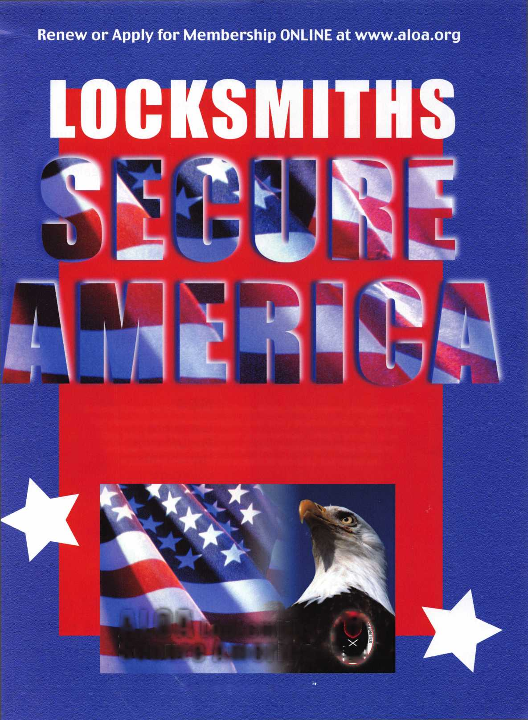

**Your**

**Key to**

**Unlocking**

**Ford/Mazda**

**Transponder**

**P rof** 1**1 s ■** • **i**

**You're never on your own..**

**Toll Free Tech Support**

**1**-**800**-**342-5080**

I've lost my Taurus keys.,

can you make a new set?

IV

How much of your money  
have you sent to the  
local Ford dealer?

8008LA New Generation STAR

Use the Ford factory tool to  
program transponder keys for  
ALL Ford/Mazda vehicles.

Keep the money in your pocket!

NGS

Complete  
Ford/Mazda  
transponder  
coverage

PLUS the

ability to  
clear ALL  
Diagnostic

Service Codes

Say "YES" to  
$100 phone calls



HICKOK

